PROJECT REPORT

PROJECT NAME:

HOUSING AND RENT MANAGEMENT SYSTEM

**PROJECT BY:**

**PRANAV RAVINDRA BUDHKAR(A20405808)**

**VINEET JITENDRA SAMPAT(A20402683)**

**Table of Contents:**

|  |  |  |
| --- | --- | --- |
| **Sr No** | **Topic** | **Page No** |
| *1* | *Aim of Project* | *3* |
| *2* | *Description of Project* | *3* |
| *3* | *Project Scope* | *5* |
| *4* | *Classes Used* | *7* |
| *5* | *Login Credentials* | *8* |
| *6* | *Execution Steps* | *8* |
| *7* | *Individual Role in Project* | *8* |
| *8* | *ERD* | *9* |
| *9* | *Use Case Diagram* | *10* |
| *10* | *Screenshots(Demo)* | *12* |
| *11* | *Validations* | *31* |
| *12* | *Future Scope* | *34* |
| *13* | *Conclusion* | *34* |

AIM:

To develop Housing and Rent Management System using JavaFx. The system can be used by Housing and Renting establishments that can help them as well as Residents to make use of services and facilities more user friendly rather than involving manual operations.

DESCRIPTION OF PROJECT:

The Housing and Rent Management System involves Registration page for the New Residents who wishes to rent a flat in our Housing establishment. This includes details like their First Name, Last Name, Contact details, Email address, SSN, Resident Type. These details itself are the check points for our Housing Staff so we can have details of the Residents who are with us and their entire background check.

In our System, New Resident can be registered by both Admin which is Housing Staff as well as user can register. This gives feature flexibility to both Residents as well as Admin if they want any information to be updated or changed.

Housing Staff can update the Resident details like Contact Number as well as Email -ID so that they can get regular updates regarding their Rent, payments, Complaints or Maintenance request raised if any.

This would help both Housing Staff as well as Residents to keep track of their request made. Our Housing establishment has 5 Row Houses with each row houses having 8 flats.

Whenever any New Resident joins our Housing then he needs to sign Lease Contract which has Lease start date, end date, Booking Amount and Balance Booking Amount and Lease ID is uniquely assigned to each of the Resident. Each Resident has unique Resident ID so that our Housing Establishment can easily identify them.

We have feature like if Resident who signs the Lease and does not pays Booking Amount at one time which is 400 dollars can maintain Balance, which can be later updated using Update Lease functionality.

If any Resident wants to sub-lease, then the Housing Staff can also update their Lease date. If any Resident leaves our housing establishment in the middle of the year, then we can update their Lease date.

We have the feature that if Resident leave then all its details and his user details would also be deleted this helps us to maintain the records rather than any kind of redundancy. Also in the future if any user wants to join they need to create their account with us again.

We have kept the Feature of raising complaints and Maintenance through our Portal so that Resident does not need to come in person or make any call to our Housing establishment. They can monitor their requests easily.

Both Complaints and Maintenance request can be added by Residents as well as Housing Staff admin. We have 6 types of Maintenance so that can be easy for our Housing staff to assign correct people to the correct task and close it accordingly.

We have also feature that request or any kind of complaints which are made can be tracked easily and once they are resolved cannot be opened. So, if any one wants to update or change but the request is closed needs to open a new request.

We have fixed Rates for 1bhk, 2bhk,3bhk and 4bhk flats and we also have one rule that if the Resident does not pays rent by 1st of December 2017 (for Demo of this project) then a penalty amount of 200 dollars would be imposed on them and total amount calculated will be summation of Rent and Penalty amount.

A Resident can view and pay the bill accordingly if they have any penalty that would be automatically shown as pop-up when they try to pay the bill.

We have hardcoded the values for Rent Amount based on the Flat Type.

* 1bhk-$1200
* 2bhk-$1800
* 3bhk-$2400
* 4bhk-$3500

|  |  |  |  |  |  |  |  |  |
| --- | --- | --- | --- | --- | --- | --- | --- | --- |
| **HouseID** | **FlatID** | | | | | | | |
| H101 | F101 | F102 | F103 | F104 | F105 | F106 | F107 | F108 |
| H102 | F201 | F202 | F203 | F204 | F205 | F206 | F207 | F208 |
| H103 | F301 | F302 | F303 | F304 | F305 | F306 | F307 | F308 |
| H104 | F401 | F402 | F403 | F404 | F405 | F406 | F407 | F408 |
| H105 | F501 | F502 | F503 | F504 | F505 | F506 | F507 | F508 |

**Static House Tables and Flat Table**

PROJECT SCOPE:

This Project can be used for all the Startup Housing establishments and Renting System for whom these features, and functionalities will act as an added advantage for them and will attract more and more Residents that would enhance their profits and Business.

This Application has features like User/Resident login and if its new Resident then it can register, where all details can be added by them and housing staff can update them and delete them if they leave housing establishment.

For New Residents there would be Lease contract creation, updation as well as deletion. Residents have facility to add complaints if they face any issue in the Housing establishment, Maintenance services request and view their rent bill based on their flat type and pay the rent accordingly.

Our Housing and Rent Management System Application can be accessed by 2 types of user:

* Housing Staff(Admin)
* Resident(User)

Housing Staff which is acting as Admin in our Application has following controls:

1.Registration: Admin can register the Residents on their behalf which includes adding them in the User Database and Residents Table.

2.Lease Creation: Addition of New Lease contract for the New Residents, Updation of lease contract for the existing Residents and delete their Lease if they move out from our Housing.

3.Complaints Creation: Admin can create the Complaints for the residents on their behalf, update their Status and date time accordingly, Delete the Request once the complaint has been solved.

4.Maintenance Creation: Admin will create the service request on behalf of the residents, update its status and last updated date time and delete the maintenance request once its resolved or closed.

5.Admin will have Database View for Residents, Complaints, Lease and Maintenance that will give Admin idea regarding their current Residents and their status worked upon.

**Residents:**

1. Residents can add Complaints from their end.
2. Residents can register themselves for our Housing Establishment.
3. Residents can add Maintenance Request from their end.
4. Residents can view their current month Rent Bill (December 2017)
5. Residents can pay the Rent bill after viewing.

Main Menu for Pranav & Vineet Housing and Rent Management System

* Admin Dashboard
* Admin Login
* Manage Residents (Add, Update, Delete)
* Manage Lease (Add, Update, Delete)
* Manage Maintenance (Add, Update, Delete)
* Manage Complaints (Add, Update, Delete)
* Admin Logout

* Resident Dashboard
* New Resident Registration
* Resident Login
* Add Complaints
* Add Maintenance Request
* View Current Rent Bill
* Pay Rent Bill

|  |  |  |  |  |  |  |
| --- | --- | --- | --- | --- | --- | --- |
| **CRUD OPERATIONS** | **USER** | **RESIDENTS** | **LEASE** | **COMPLAINTS** | **MAINTENANCE** | **RENT** |
| CREATE | Yes (ADMIN, RESIDENT) | Yes(ADMIN) | Yes(ADMIN) | Yes(ADMIN) | Yes (ADMIN, RESIDENT) | Yes (VIEW RENT & PAY RENT BILL, RESIDENT) |
| UPDATE | Yes(ADMIN) | Yes(ADMIN) | Yes(ADMIN) | Yes(ADMIN) | Yes (ADMIN, RESIDENT) | No |
| DELETE | Yes(ADMIN) | Yes(ADMIN) | Yes(ADMIN) | Yes(ADMIN) | Yes(ADMIN) | No |

Classes Used:

* Login:
* This Class includes Login of Admin as well as Resident.
* Admin Login will route to Admin Dashboard and Resident Login will route to User Dashboard.
* Registration:
* This Class includes registration of New Resident
* It further includes adding a new Resident, Updating the details of existing Resident and Delete the Resident details.
* HouseFlat:
* This Class includes details regarding 5 Row Houses and 8 Flats in each of them.
* Complaints:
* This Class includes addition of Complaints by both Resident as well as Admin.
* It also involves updation and deletion of complaints by admin.
* Maintenance:
* This Class includes addition of Maintenance Request by both Resident as well as Admin.
* It also involves updation and deletion of Maintenance by admin.

* Lease:
* This Class includes creation of Lease contract and adding New Residents by Admin.
* It further involves updation and deletion of Lease contract.
* Rent:
* This Class includes creation of Rent Bill based on Flat type which involves penalty calculation and acts as an Interface.
* The Resident can view this Rent Bill and pay the rent accordingly.

Login Credentials:

* Admin Login:
* Username: admin
* Password: admin
* Resident Login:
* Username: vineet21
* Password: vineet21

* Username: pranav
* Password: prb

Execution Steps:

* Double Click on the jar file created: “PV-HRMS.jar “
* We can also execute the file via command prompt: “java-jar PV-HRMS.jar’’

Individual Role in our Project:

* **Pranav Budhkar**
* Analyzing the Requirements of the Project
* Designing the Login, Registration, Lease Models
* Designing the DAO Models for Login, Registration and Lease.
* Designing the Controller for Login, Registration and Lease Models.
* Designing the Views and GUI’s for the above Models.
* Successfully tested the JDBC Connectivity with Databases used in the Project.
* Adding various Validation Check points for all these Models by introducing error trapping
* Unit Testing the Code with Dummy Data.
* Coding functionality for Admin that includes Registration, Manage Residents that includes Add, Update and Delete, Manage Lease that includes Add, Update and Delete
* Populating the Table views for above stated functionalities.
* Rent Bill and Payment logic development, Implementation and GUI Designing.
* **Vineet Sampat**
* Analyzing the Requirements of the Project
* Designing the Complaints, Maintenance, User welcome page functionality .
* Designing the DAO Models for Complaints and Maintenance.
* Designing the Views and GUI’s for the above Models.
* Designing the Controller for Complaints and Maintenance.
* Successfully tested the JDBC Connectivity with Databases used in the Project.
* Adding various Validation Check points for all these Models by introducing error trapping
* Unit Testing the Code with Dummy Data.
* Coding functionality for Manage Complaints that includes Add, Update and Delete; Manage Maintenance that includes Add, Update and Delete.
* Coding for Residents Adding Complaints and Maintenance.
* Populating the Table views for above stated functionalities.
* Rent Bill and Payment logic development, Implementation and GUI Designing.

ENTITY RELATIONSHIP DIAGRAM:

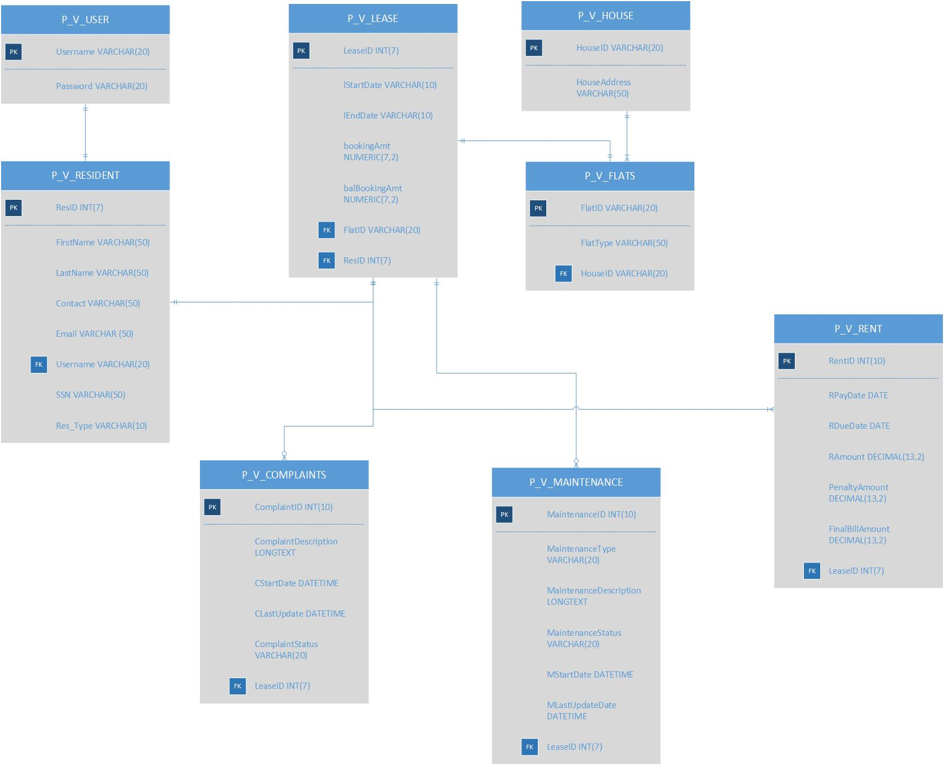

USE CASE DIAGRAM:

COMPACT USE CASE DIAGRAM:

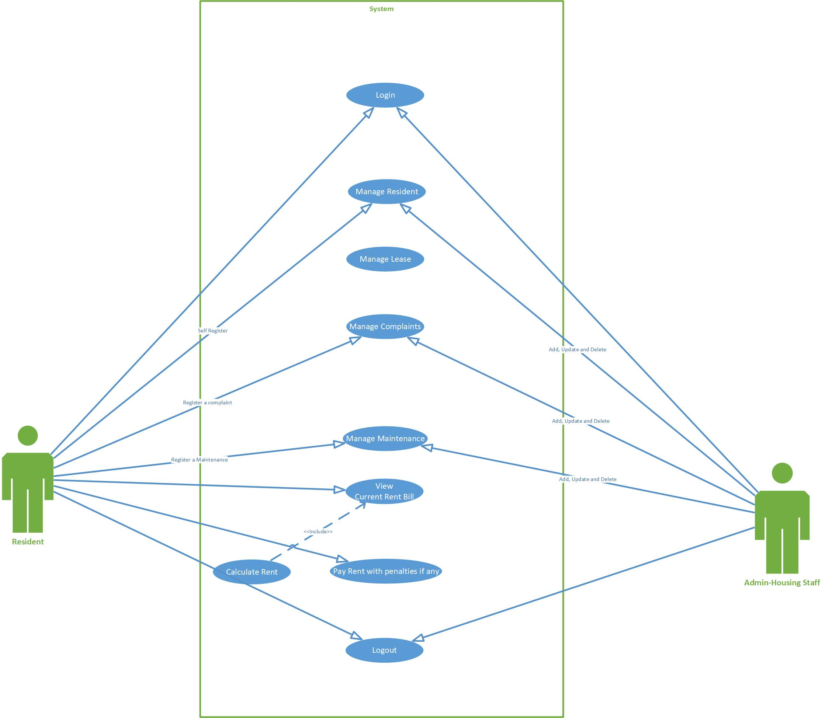

DETAILED LEVEL USE CASE DIAGRAM:

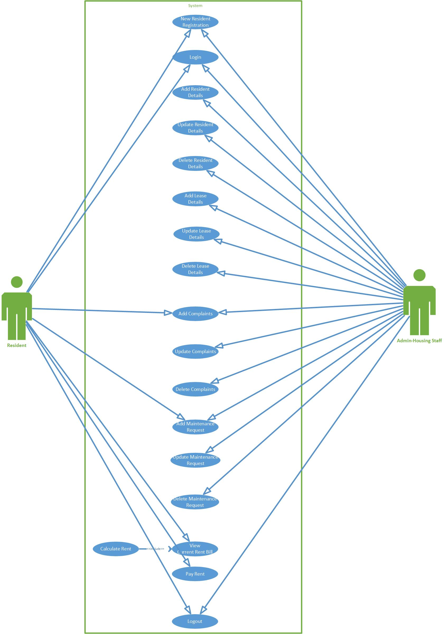

Screenshots: Application Demo

The below Screenshot is for the Login functionality of Admin where admin has rights to perform the functions as stated earlier.

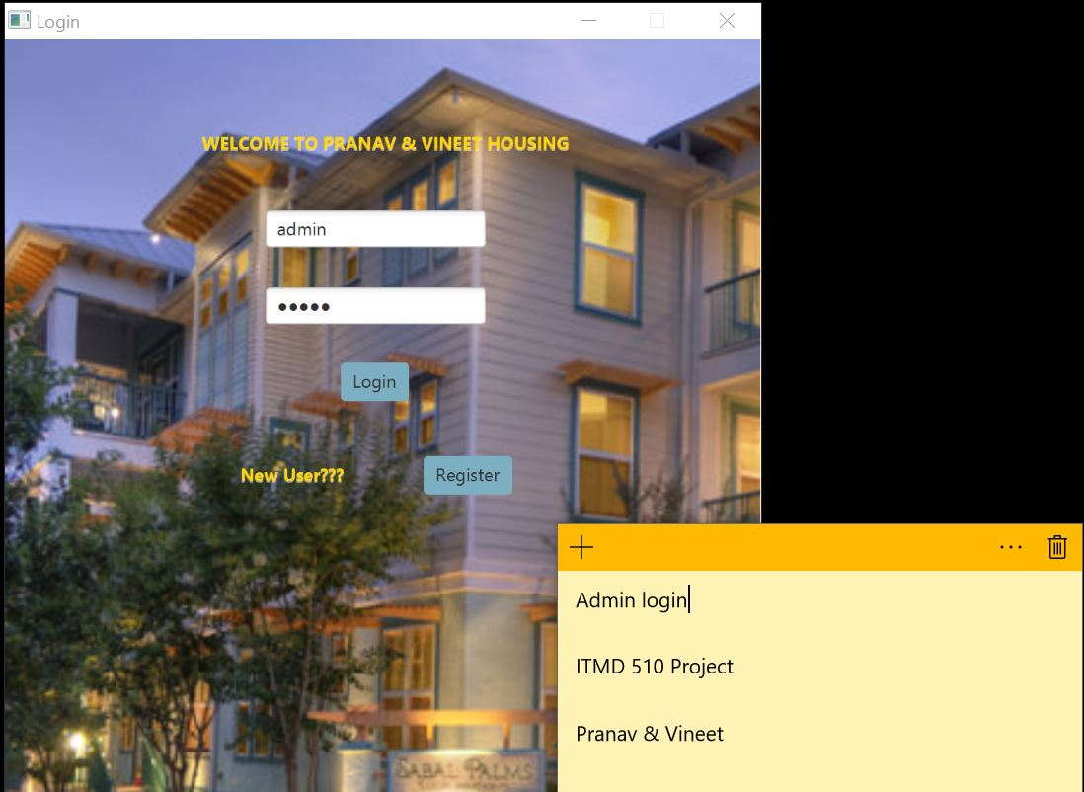

Below is the Admin Dashboard:

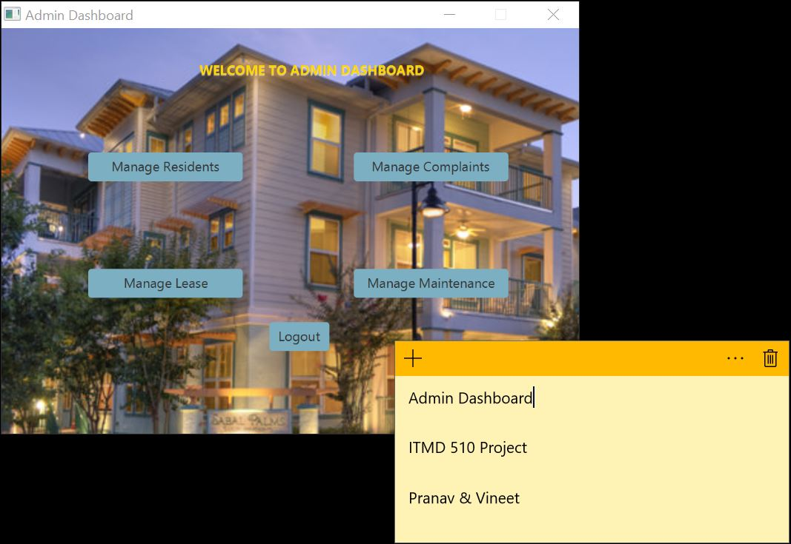

The below Screenshots are for the New Resident Addition, Updation of Details regarding existing Residents and delete Resident.

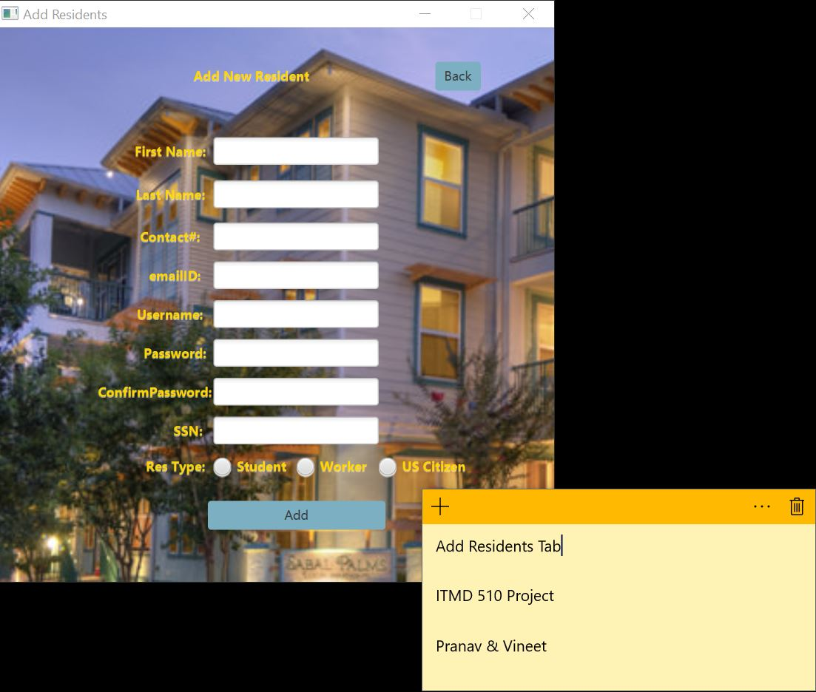

Added Resident Ravi Budhkar.

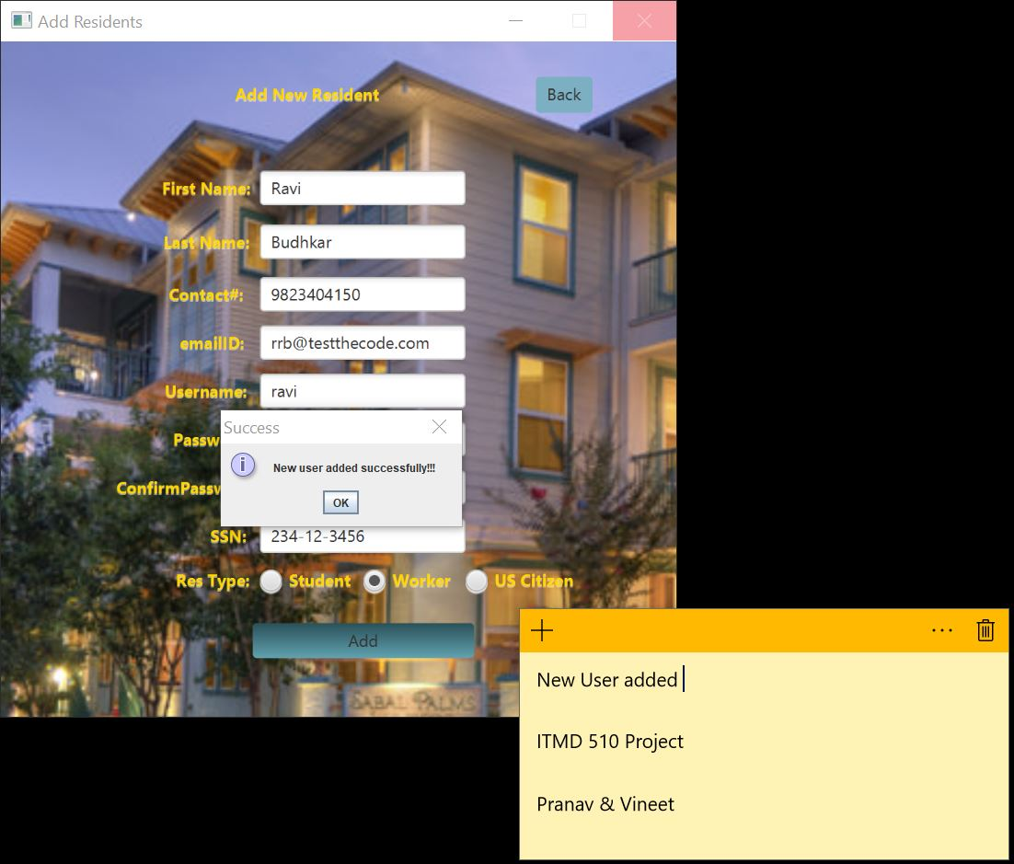

Table View showing Details of the Newly Added Resident:

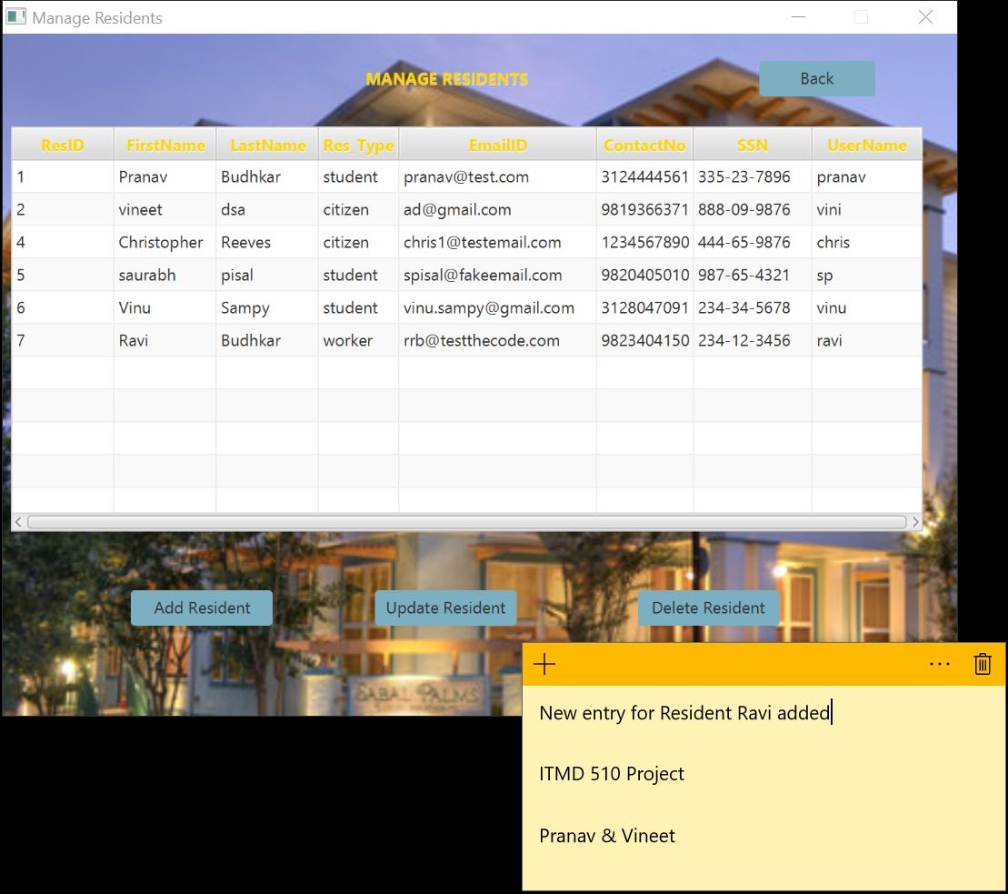

Details of Newly Added Resident updated like Email-Id and Contact Number.

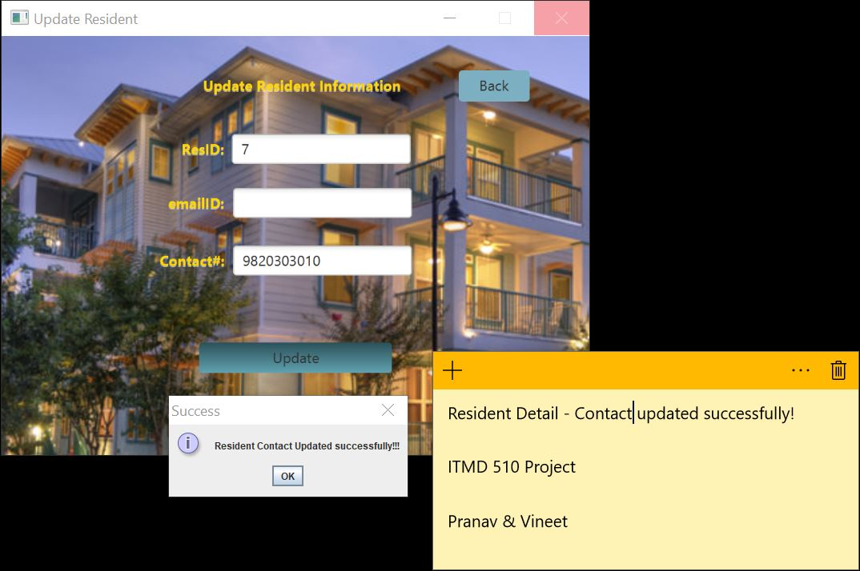

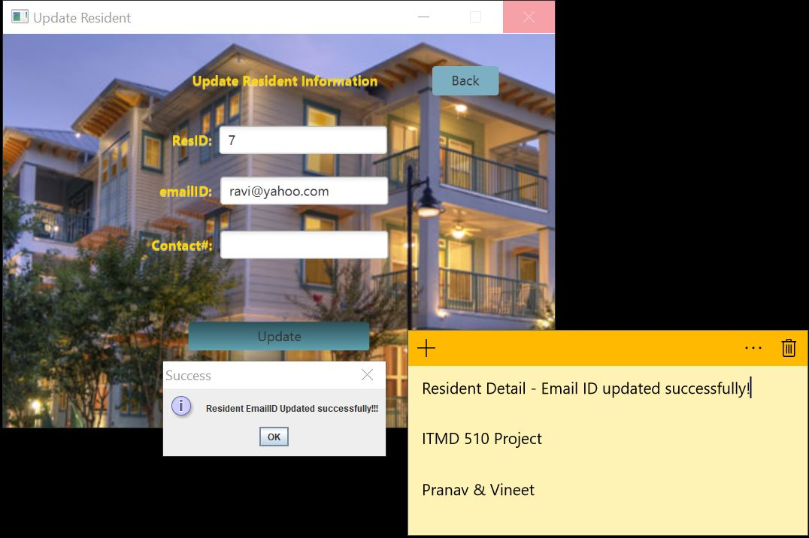

Table View showing updated Details for Ravi Budhkar:

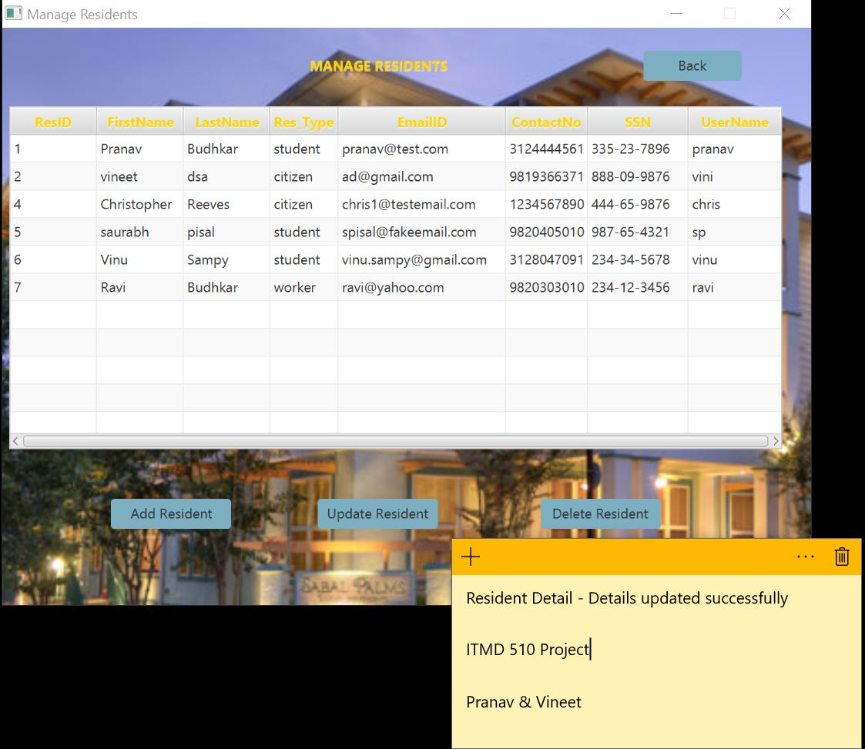

Now, we are deleting the Resident who is Ravi Budhkar from our Housing System.

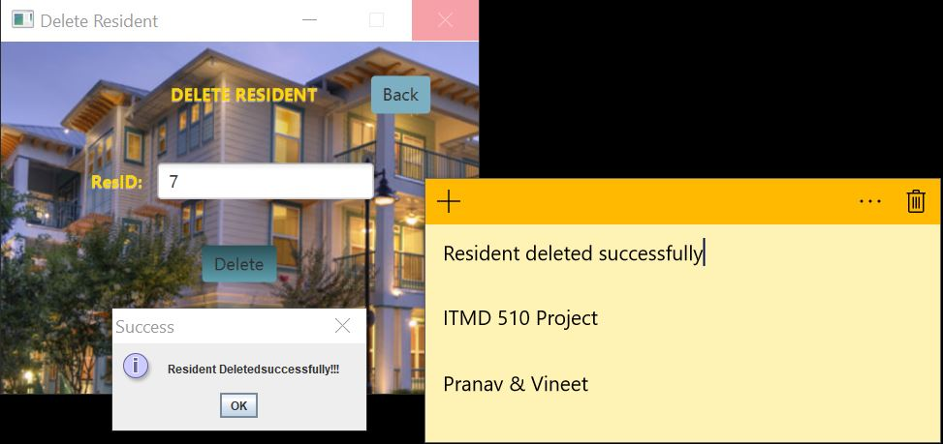

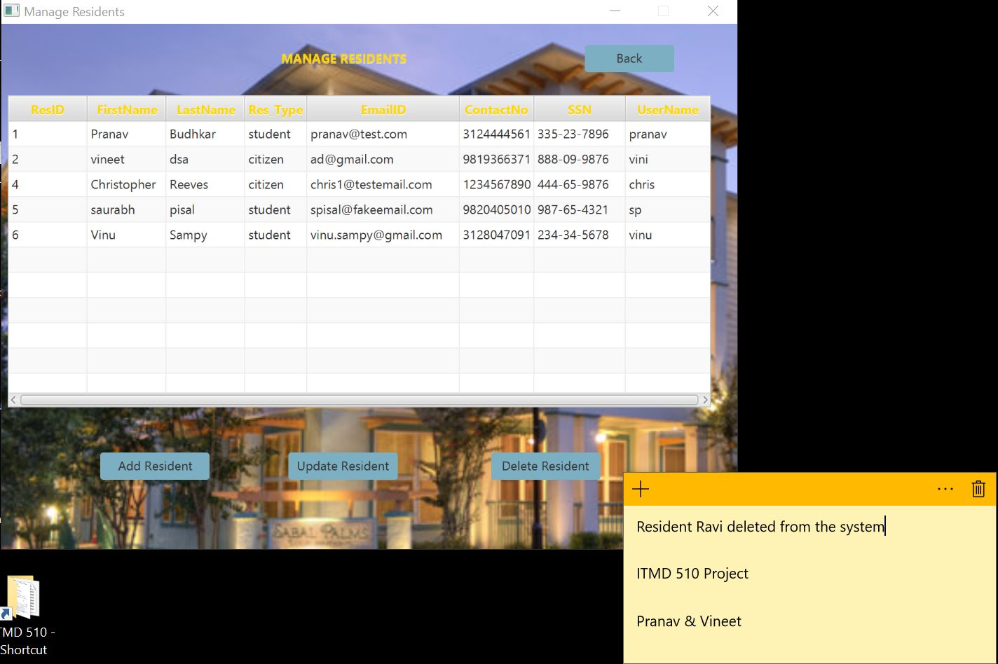

The below are the screenshots for adding Lease for Newly Registered Resident.

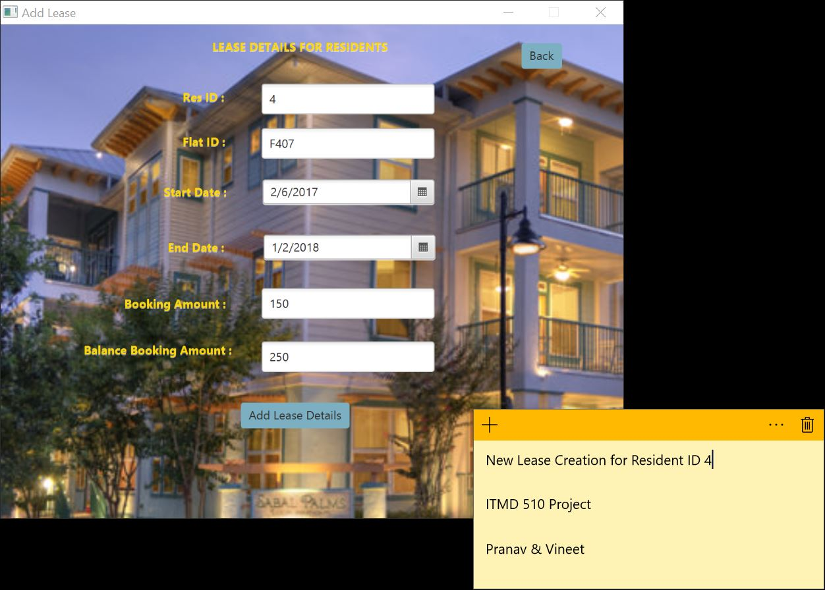

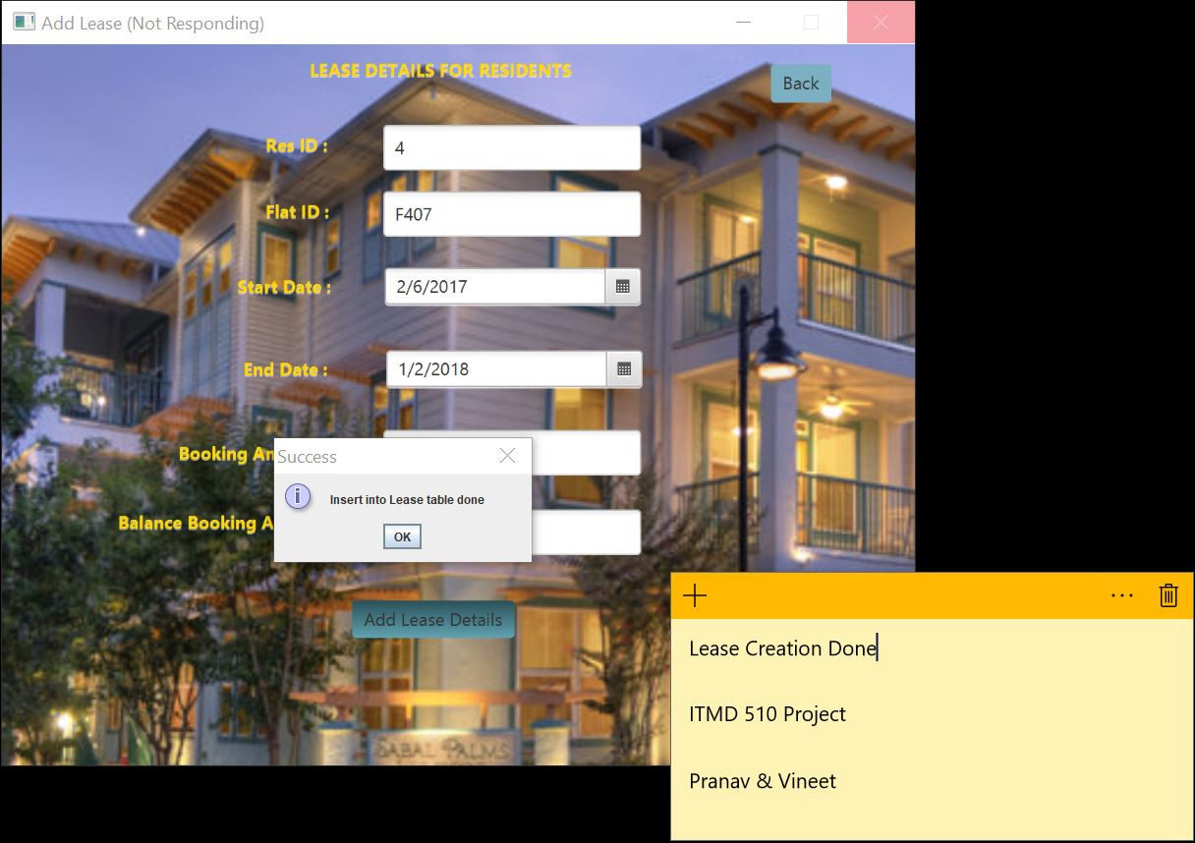

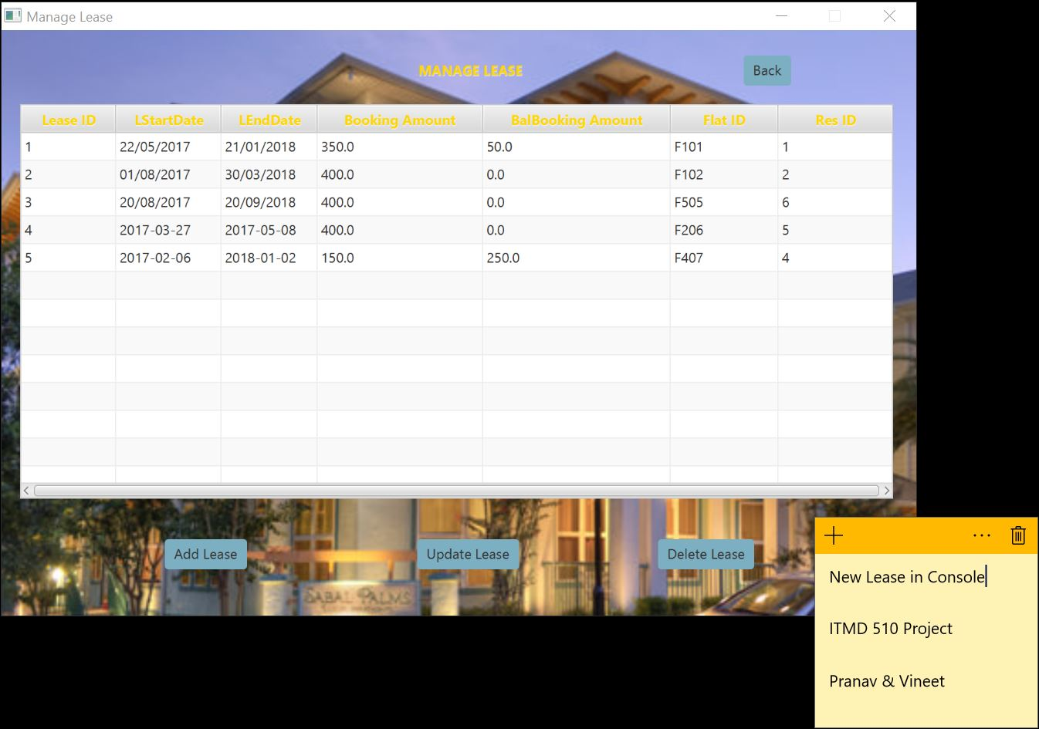

The below screenshot is for updation of Lease details where we are updating the Booking Amount where we have booking Amount of 150 and the Resident initially pay only 25 dollars which makes the Balance amount of 175 and later pays remaining entire Balance Booking Amount which is 250 and when we update the entry the balance booking amount value will get updated to 0 and the Booking Amount will get set to 400.

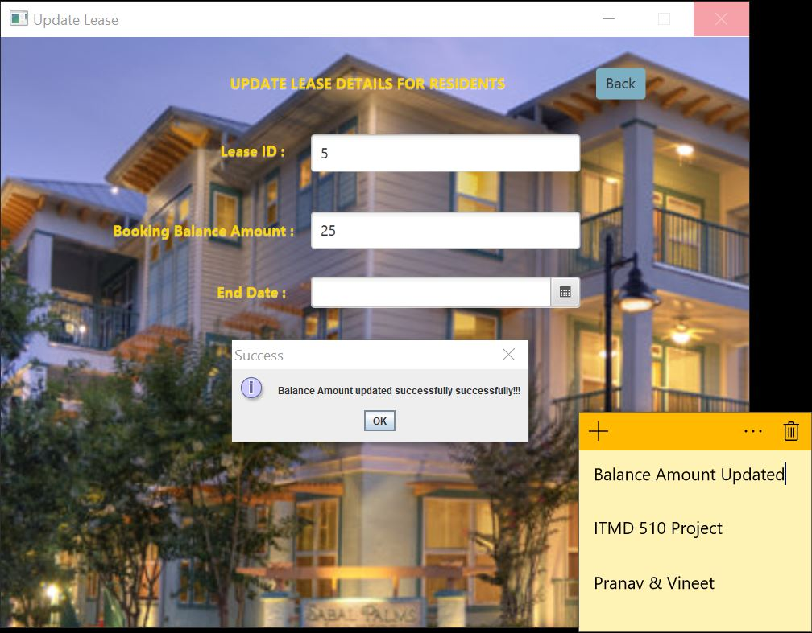

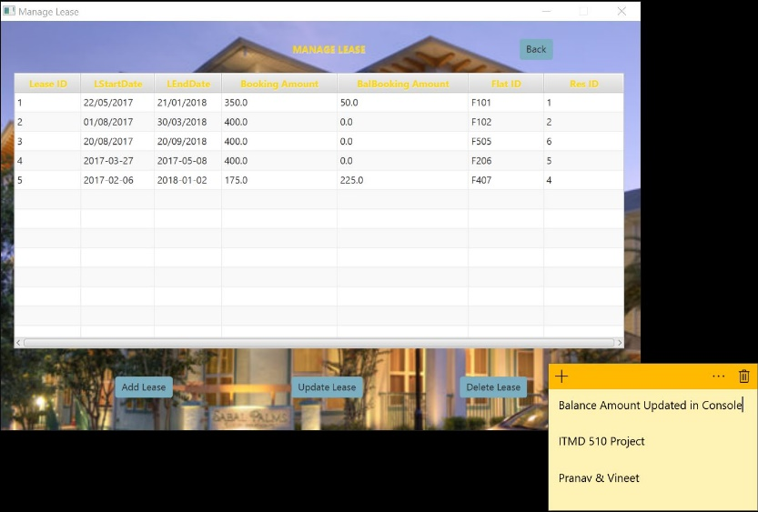

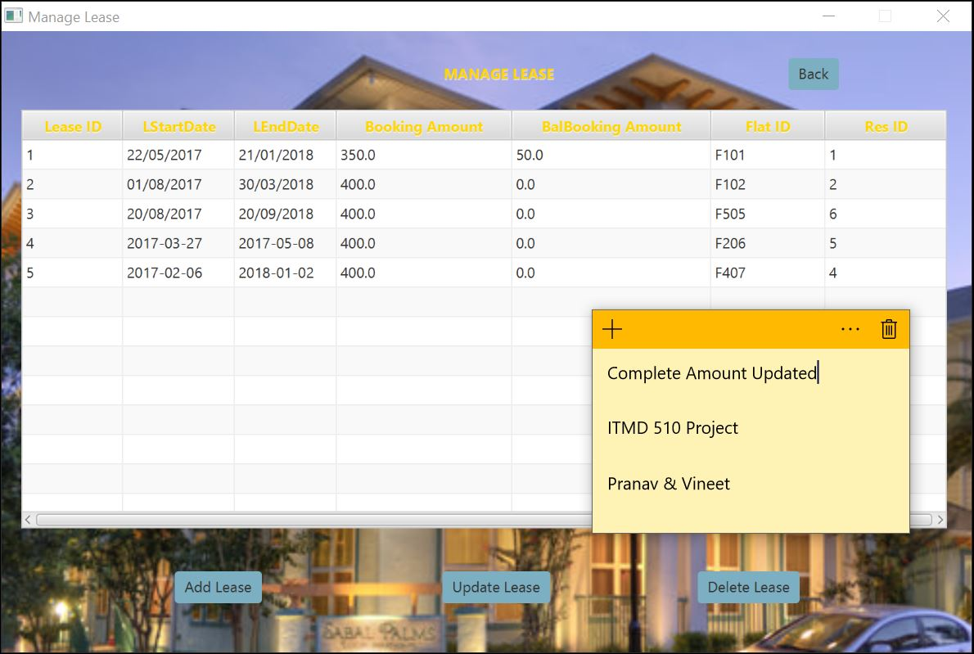

The below screenshot is for deleting the Lease of a Resident:

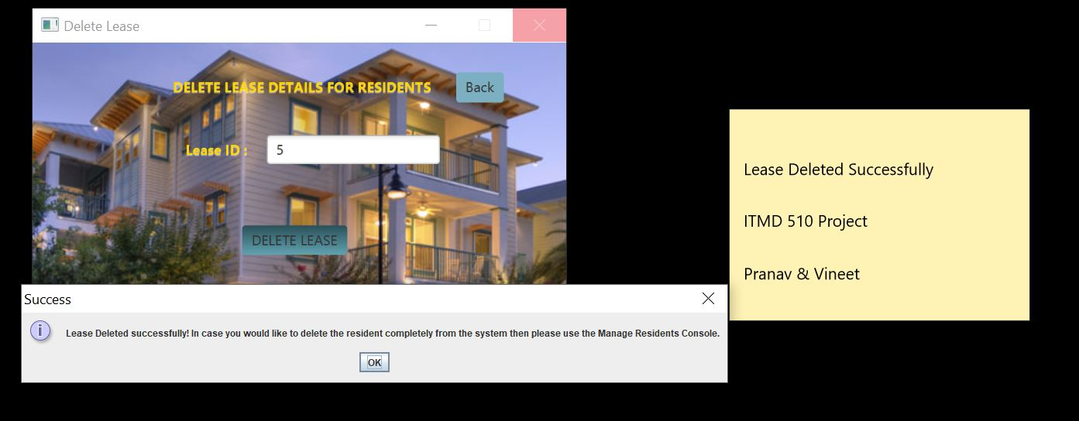

**Please note that while deleting lease the current rent will also get deleted for the resident.**

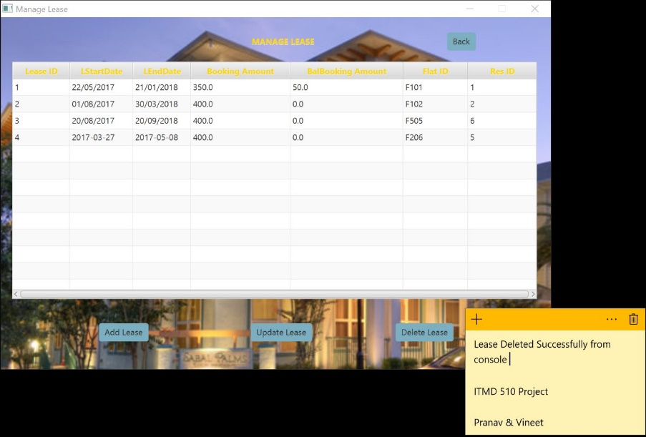

As a Resident, they can register Complaint with us as well as we can record their Maintenance Request.

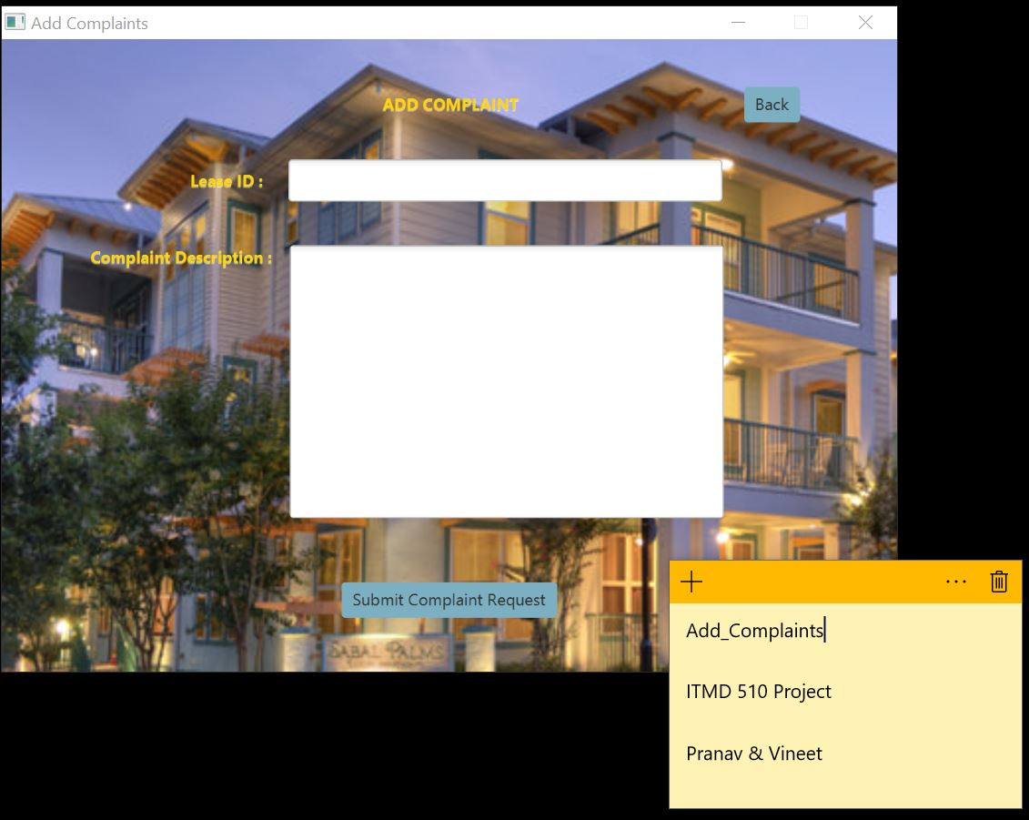

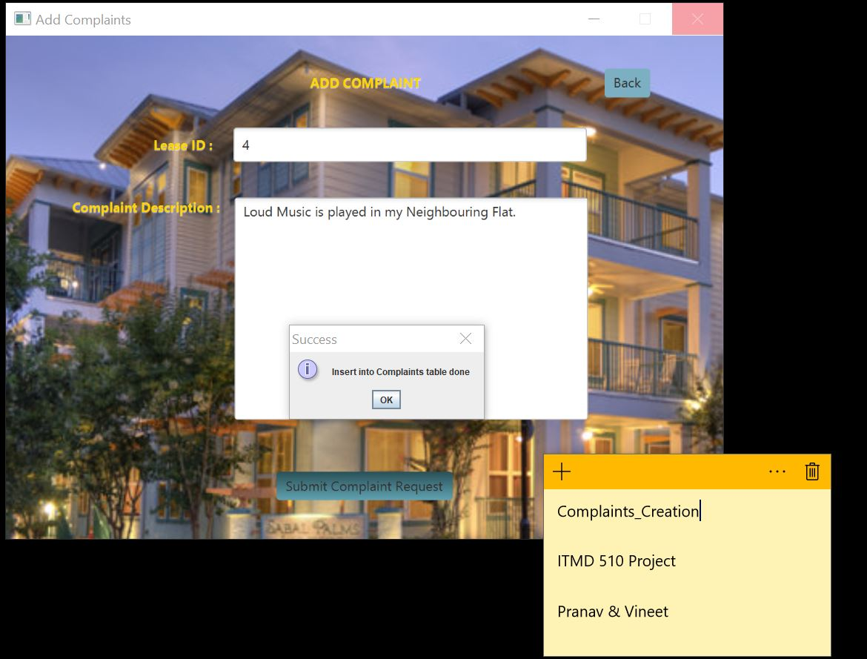

As Admin we have the right to update the Status from New to in progress and from In Progress to Resolved.

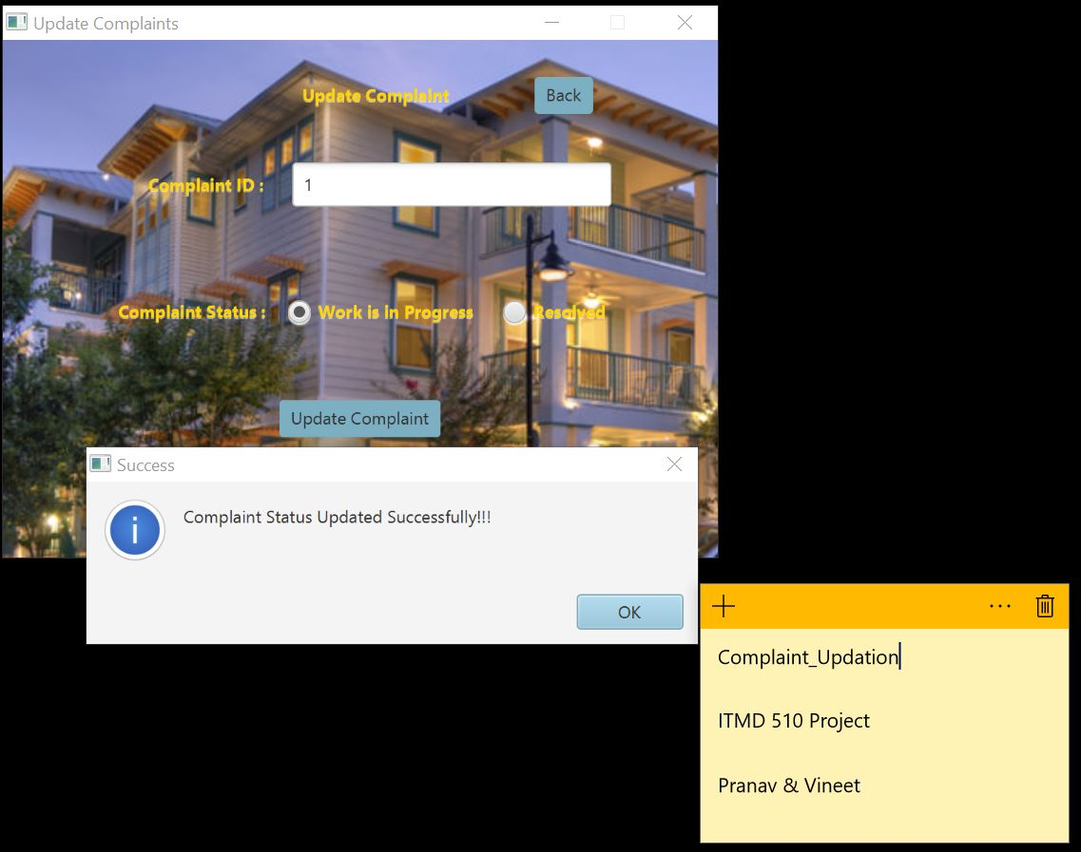

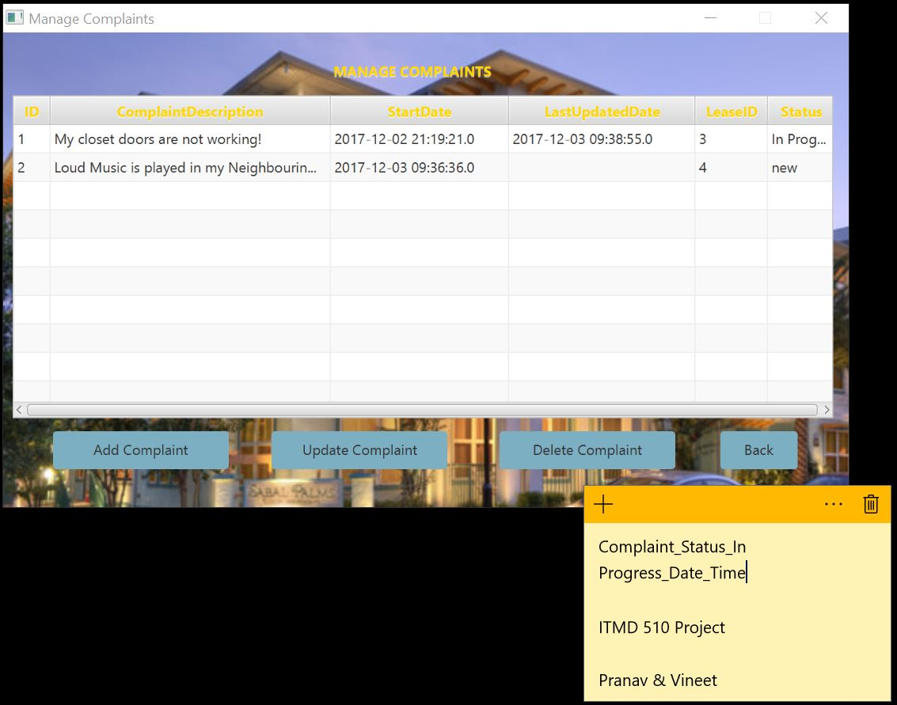

For Complaint ID 1, we have updated the Status from New to In Progress and from In Progress to Resolved.

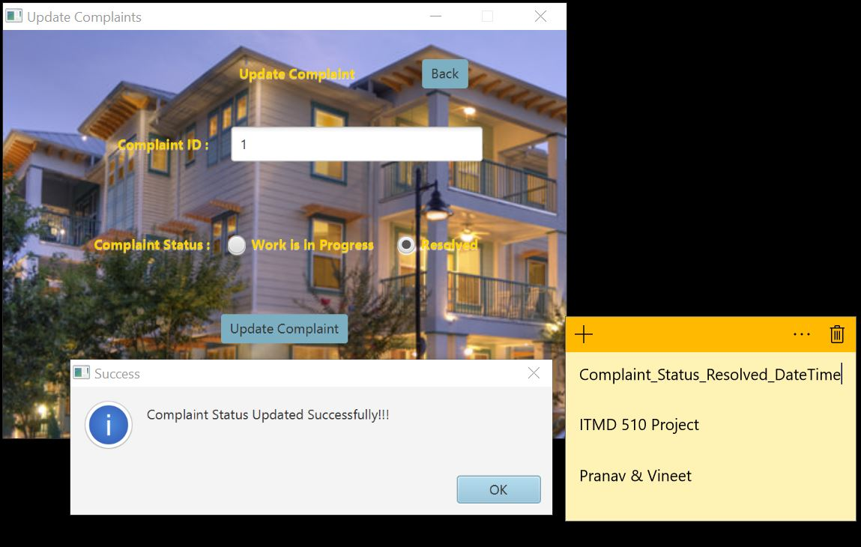

We can see the updated Table View below:

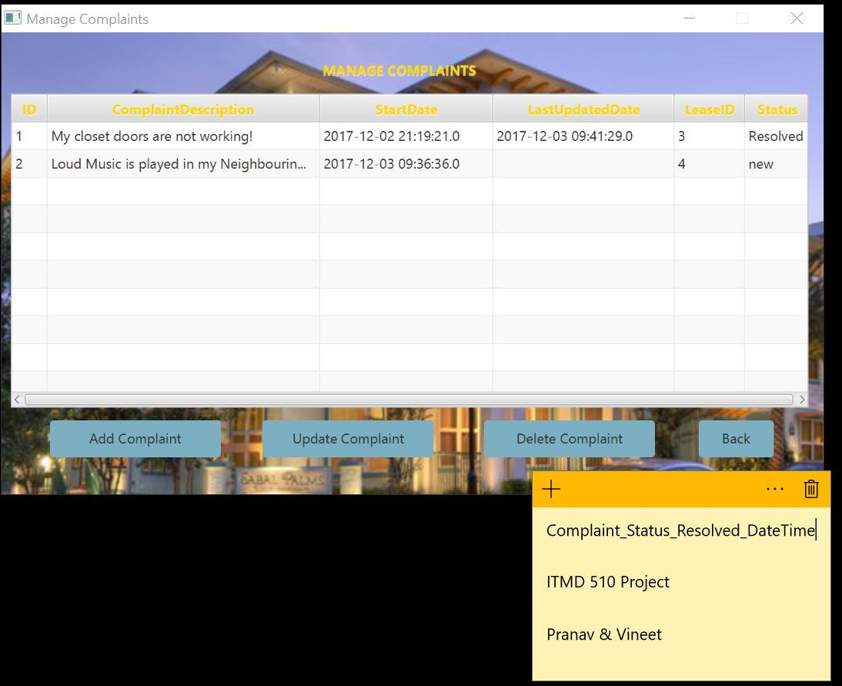

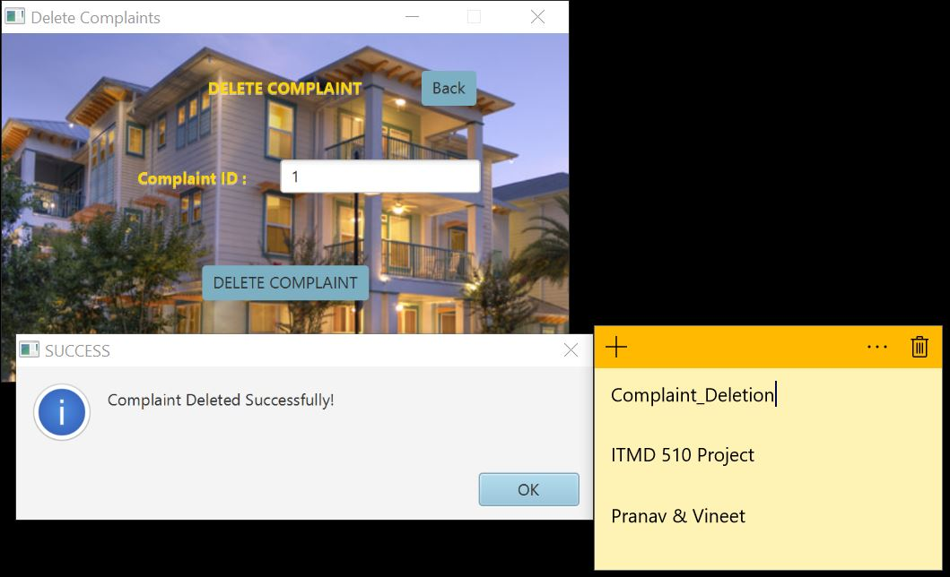

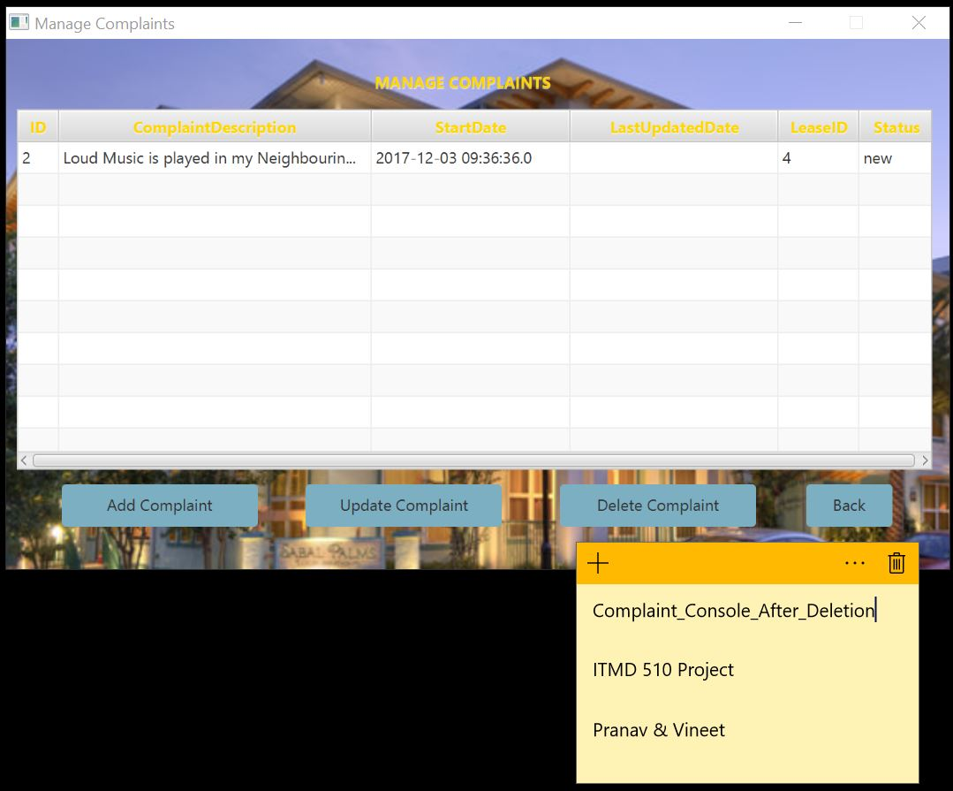

For Maintenance:

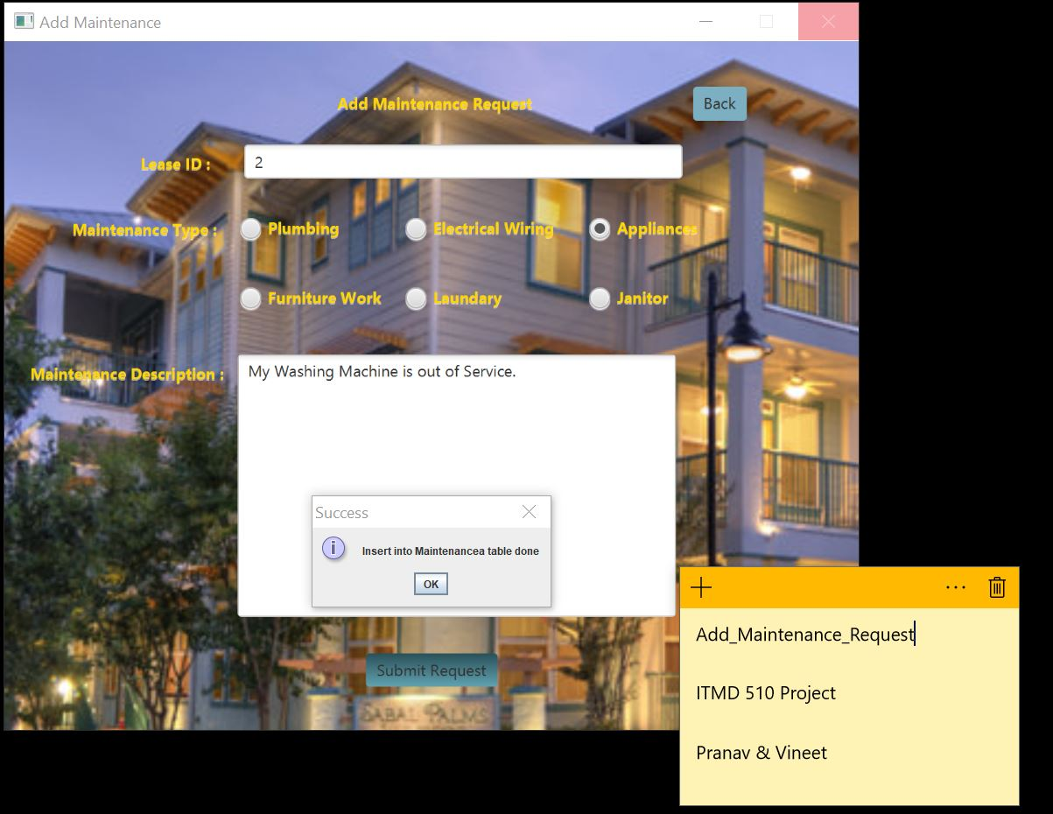

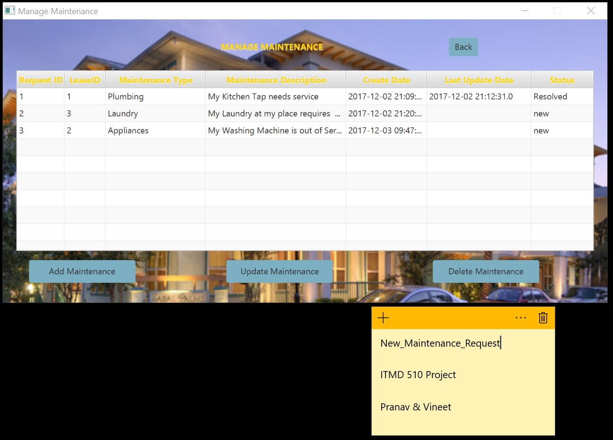

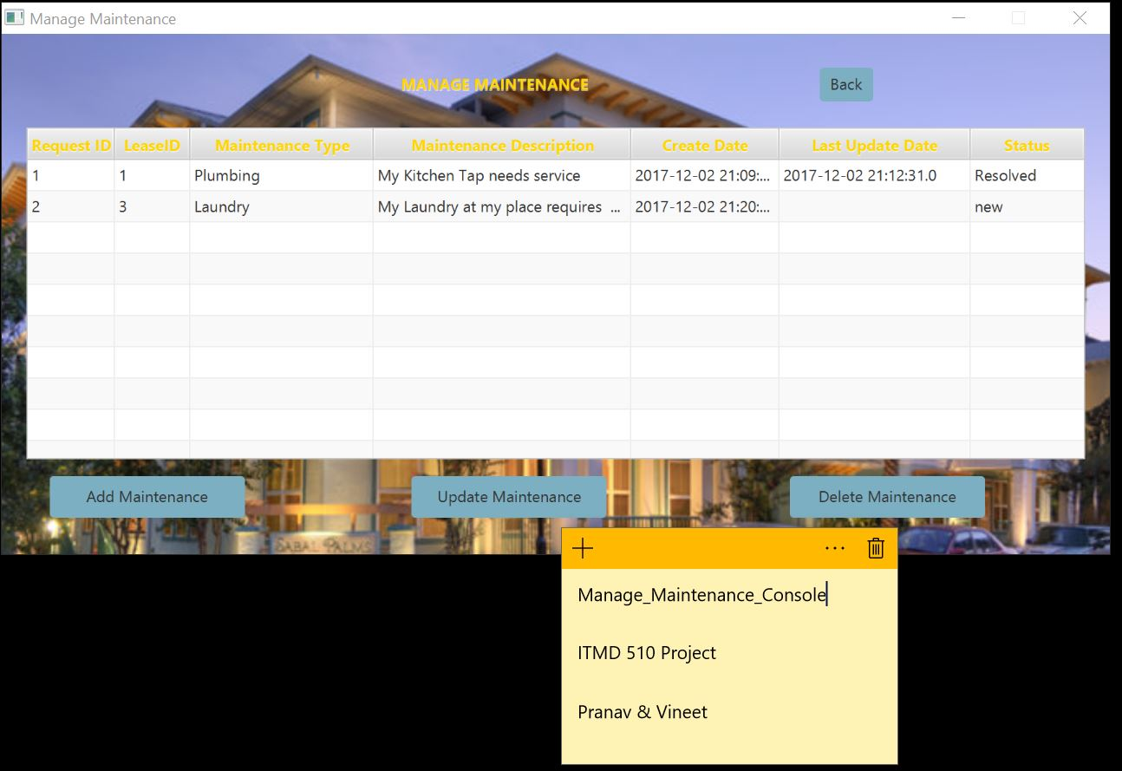

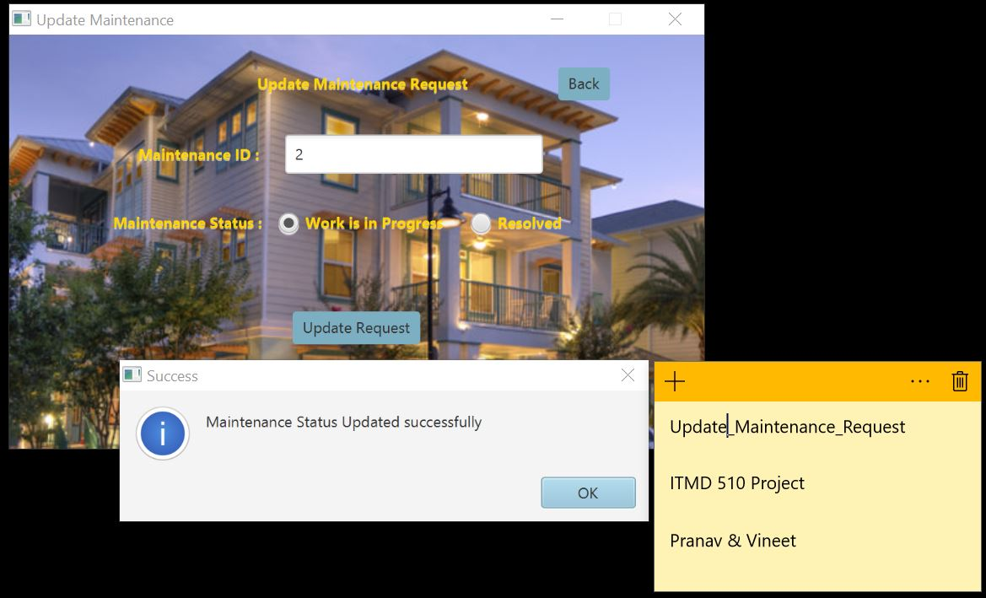

Now we are updating the Status of Maintenance Request as admin from In Progress to Resolved for Maintenance ID 2

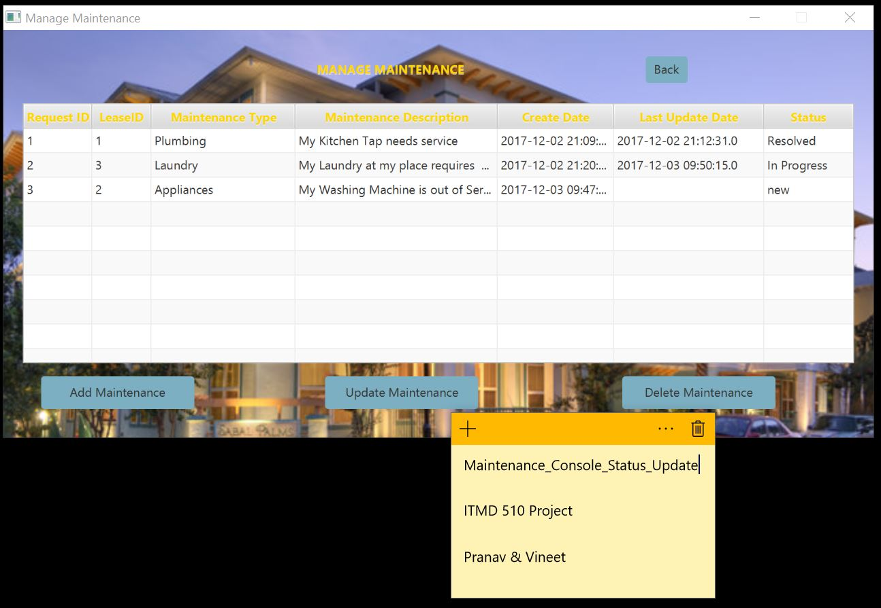

Now once we have served the Maintenance Request of the Resident we will update the Status to Resolved state.

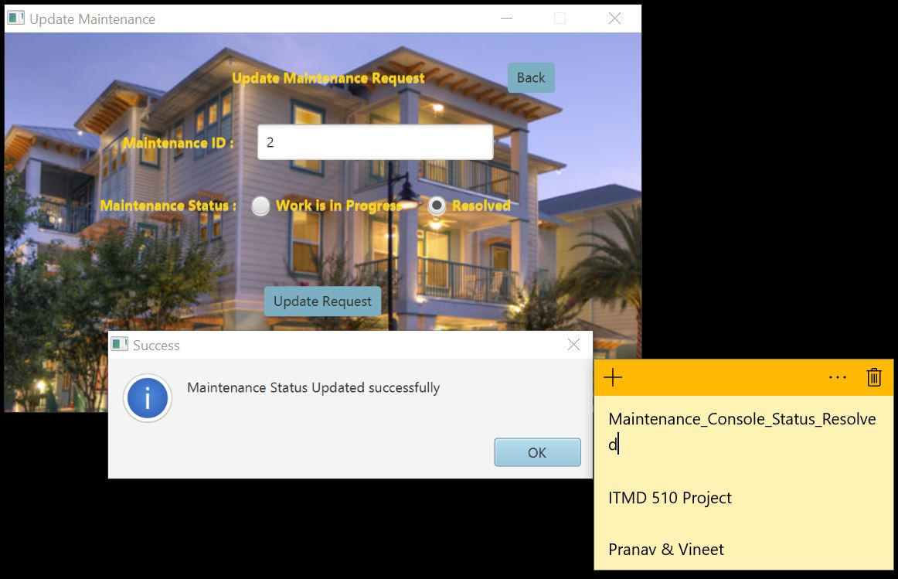

The Table View shows updated status and updated Time that will help when the request was closed and at what time it got updated which takes system date and time.

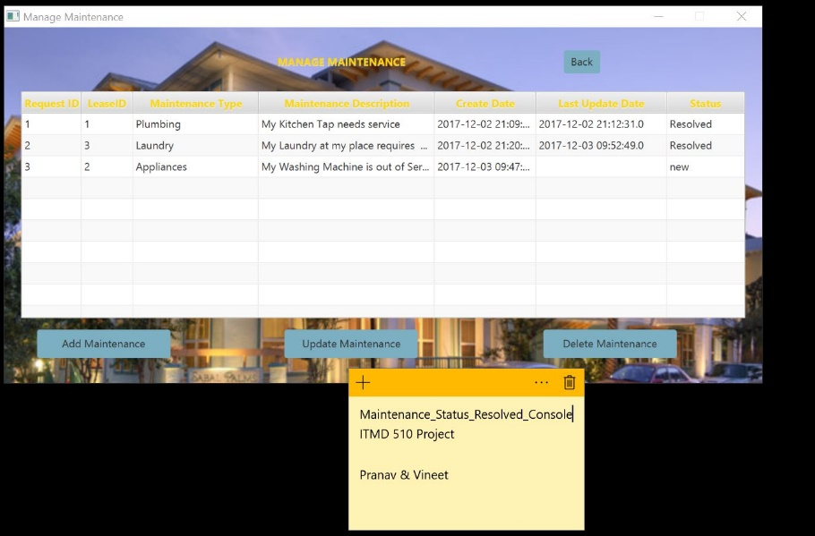

The below screenshot is used for deleting Request as that request is no longer required.

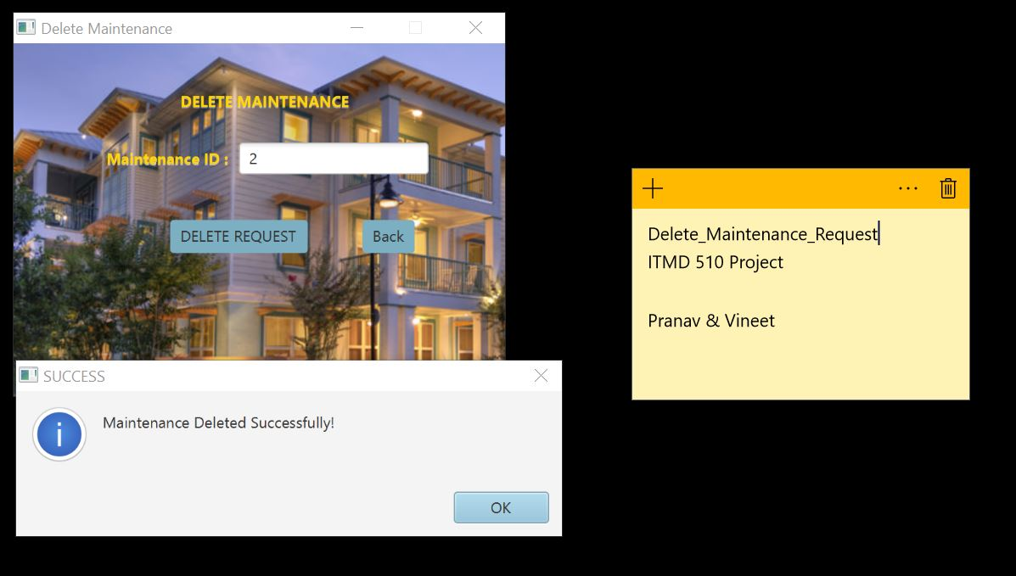

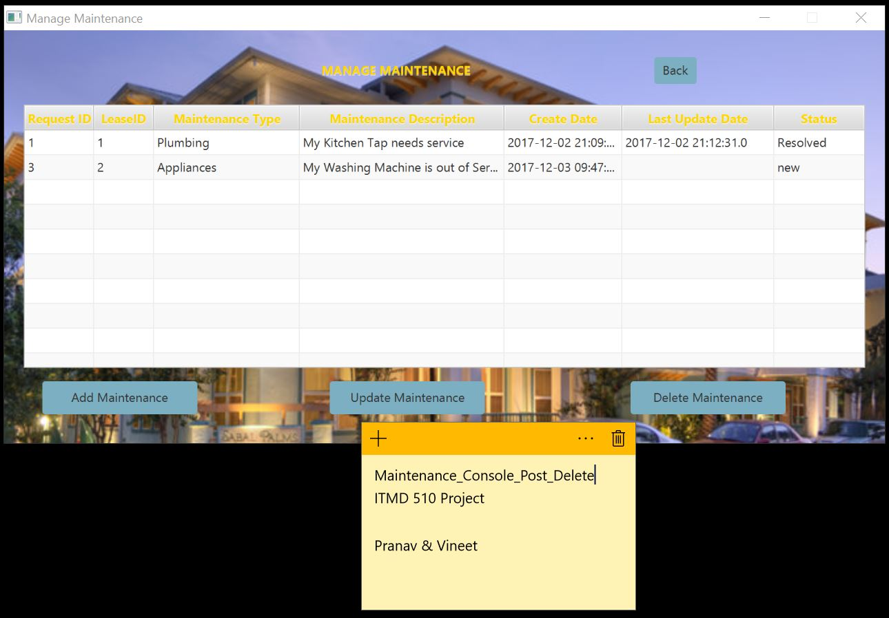

We have given the rights for the Resident who is our Customer to view their Current Rent Bill, Add Maintenance and Complaints Request.

So Now I am logging with Pranav’s credentials as Resident to Add complaints and Maintenance.

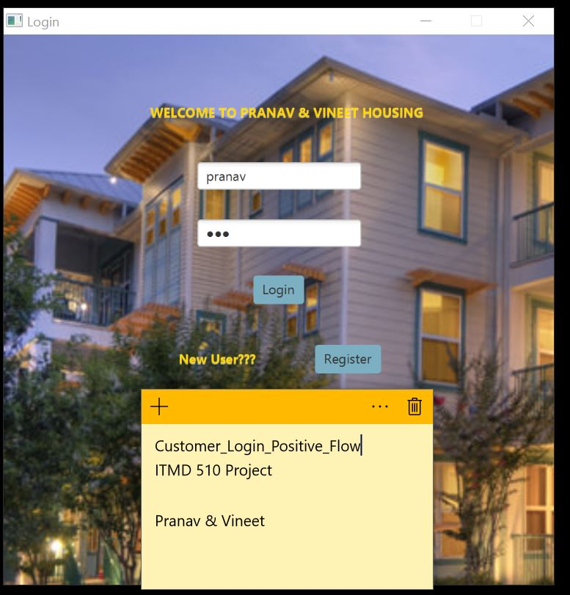

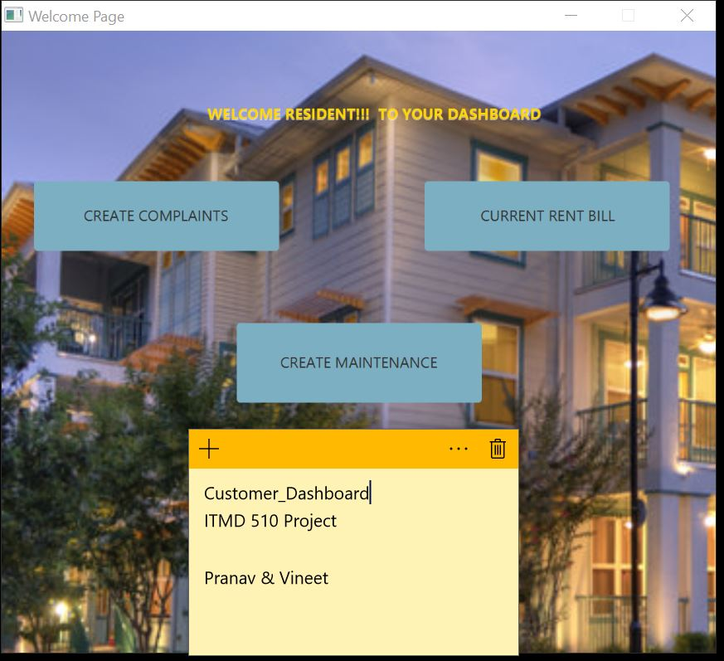

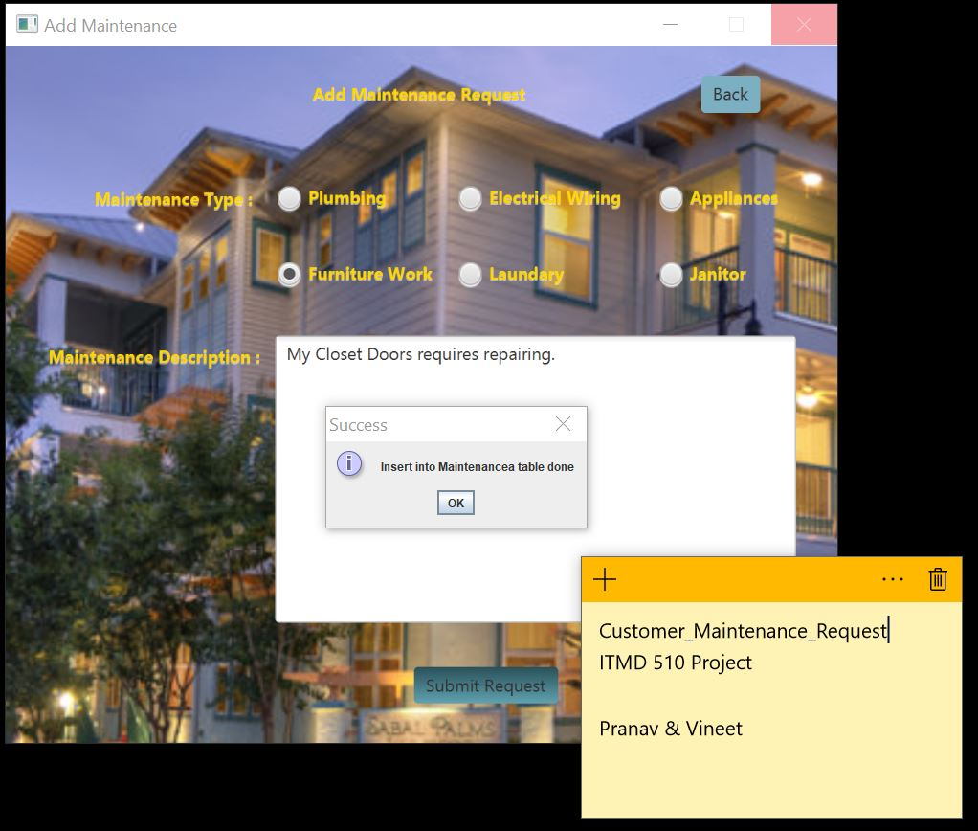

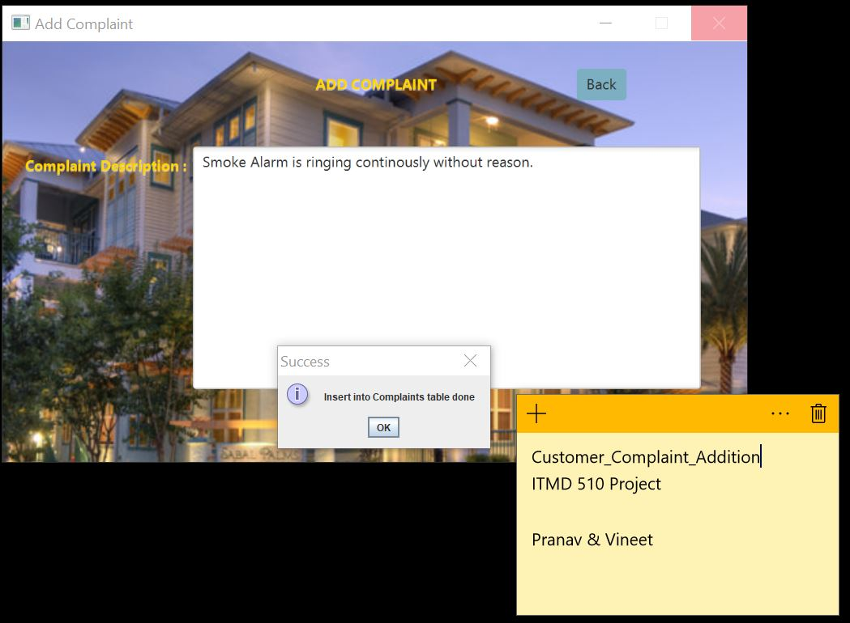

A Customer or Resident can view the Rent Bill and Pay the Bill for current Month which is December as we have set the Due Date of 1st of December 2017, so If the Resident Pays the bill before that then there is no penalty imposed else 200 dollars penalty will imposed and total bill is Rent Amount plus the penalty Amount. For Lease ID 2 and 4, we have following rent bill that Resident views the Bill for 30th November 2017 and 1st December 2017 and pays the rent then the payment would be without penalty that’s the amount Resident needs to pay.

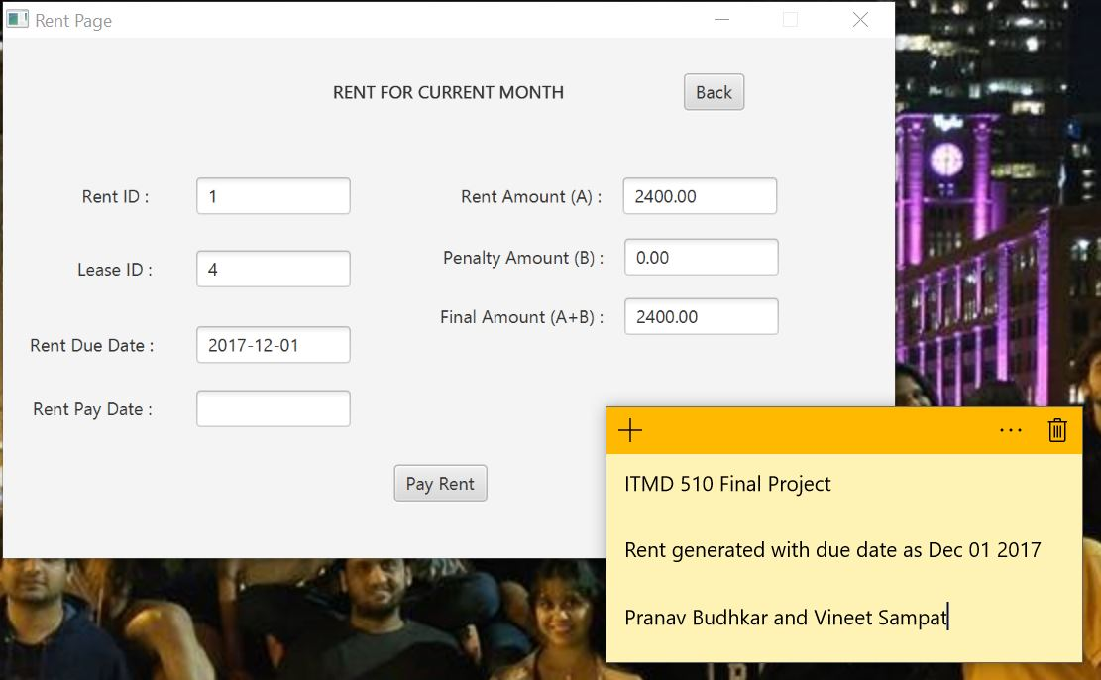

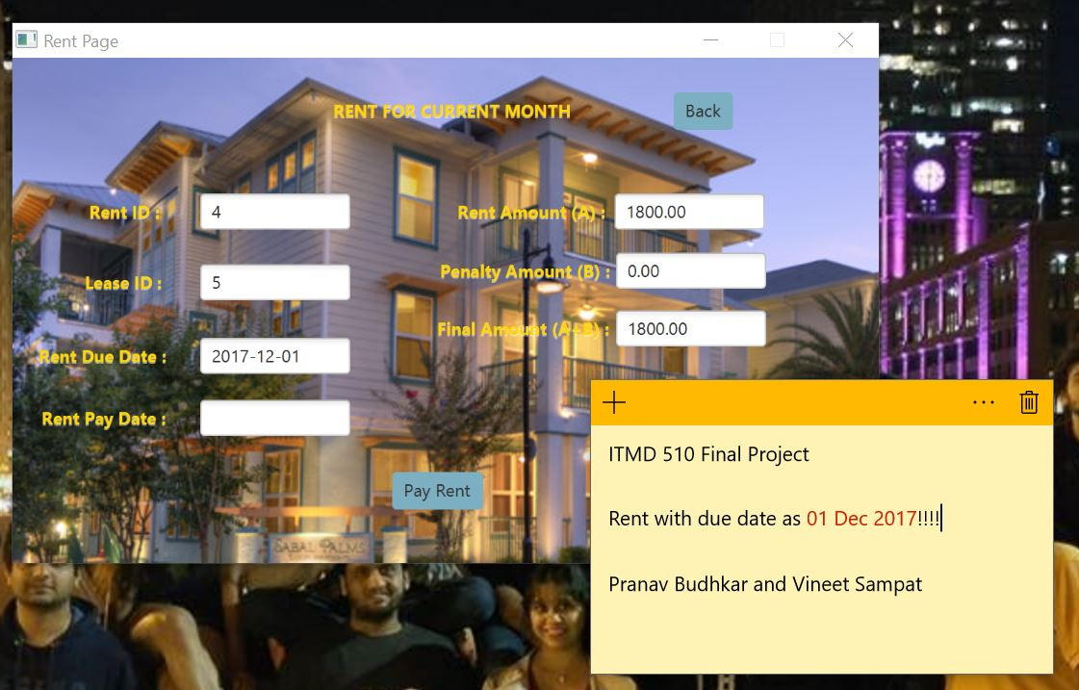

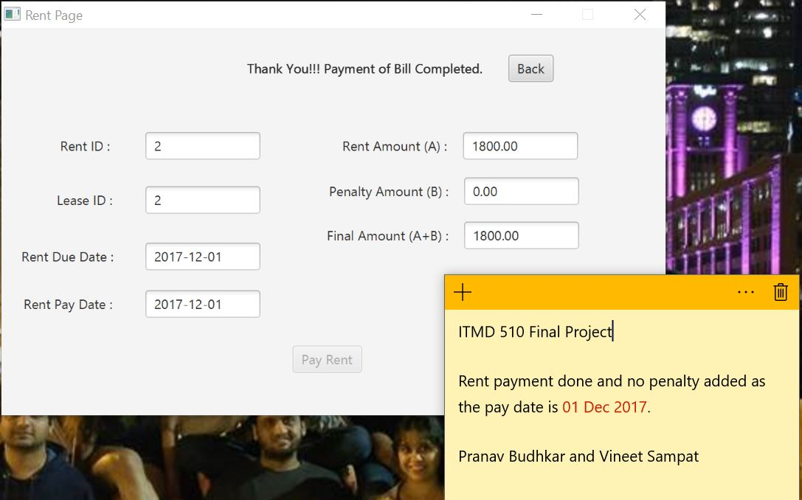

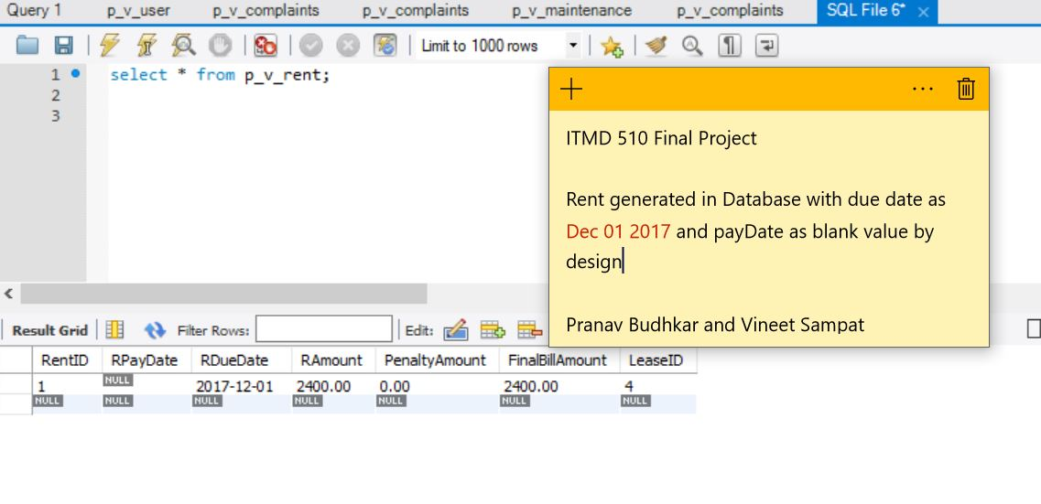

The Below is example where the Penalty is imposed as the Lease holder has payed post due date.

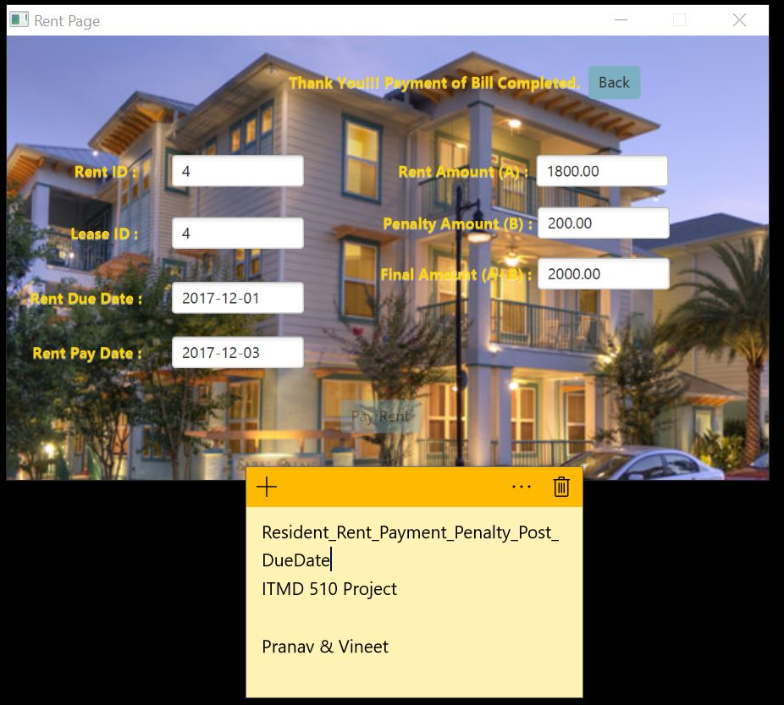

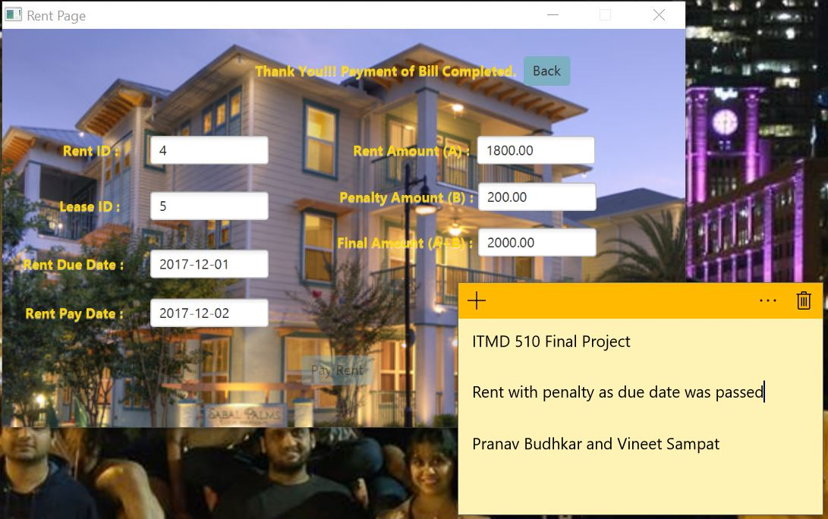

Validations for Various Functionalities:

We have added various Validation checks in our Application so that any wrong details are not entered in our Database.

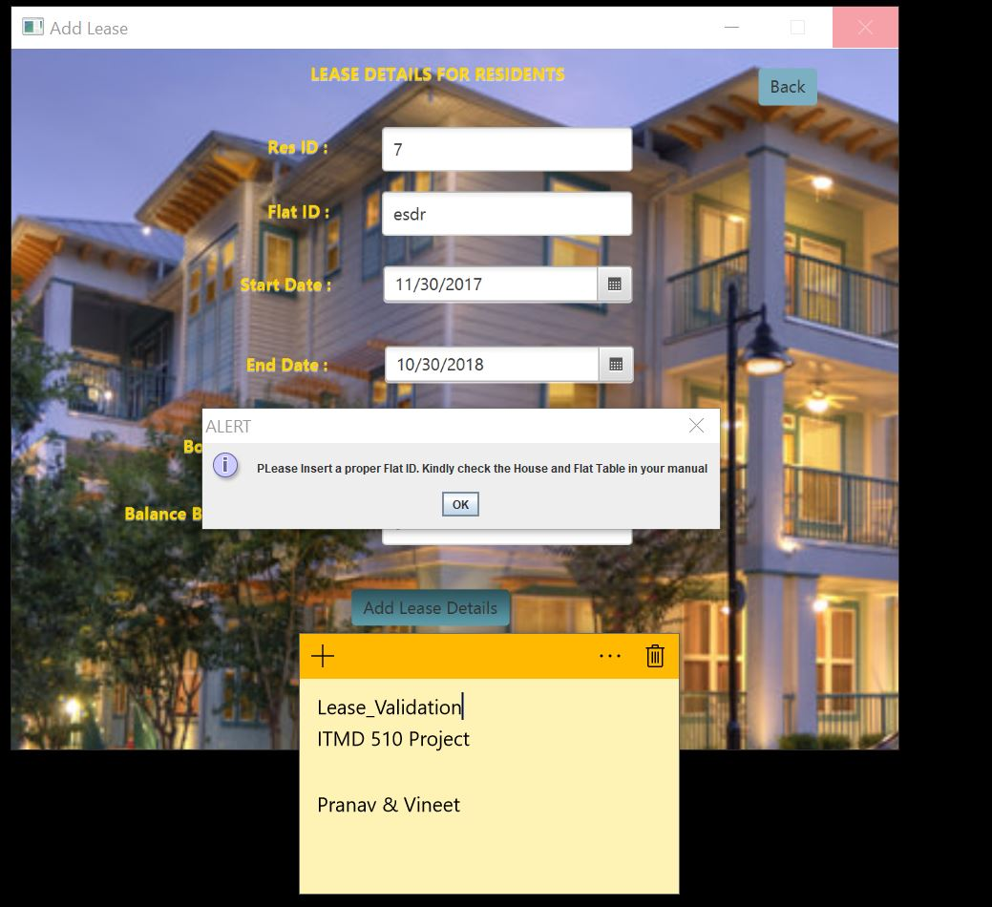

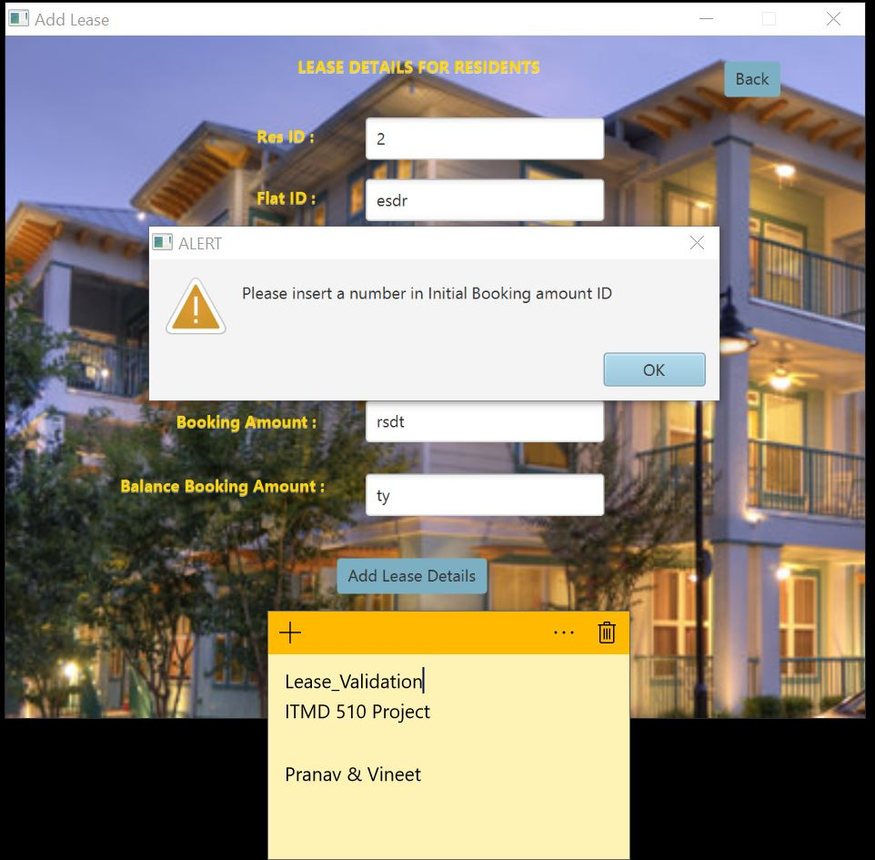

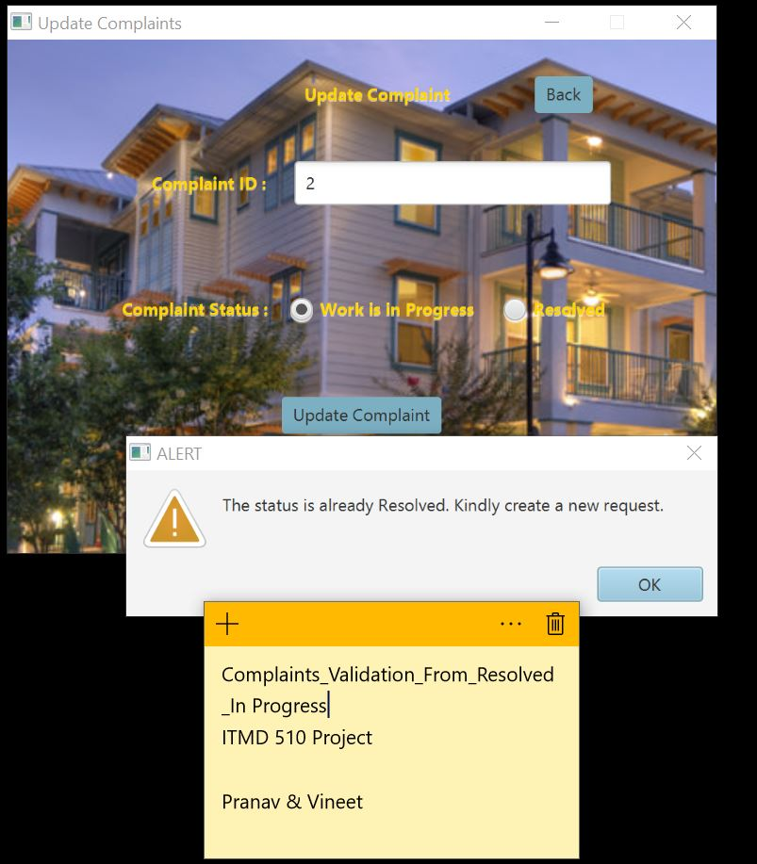

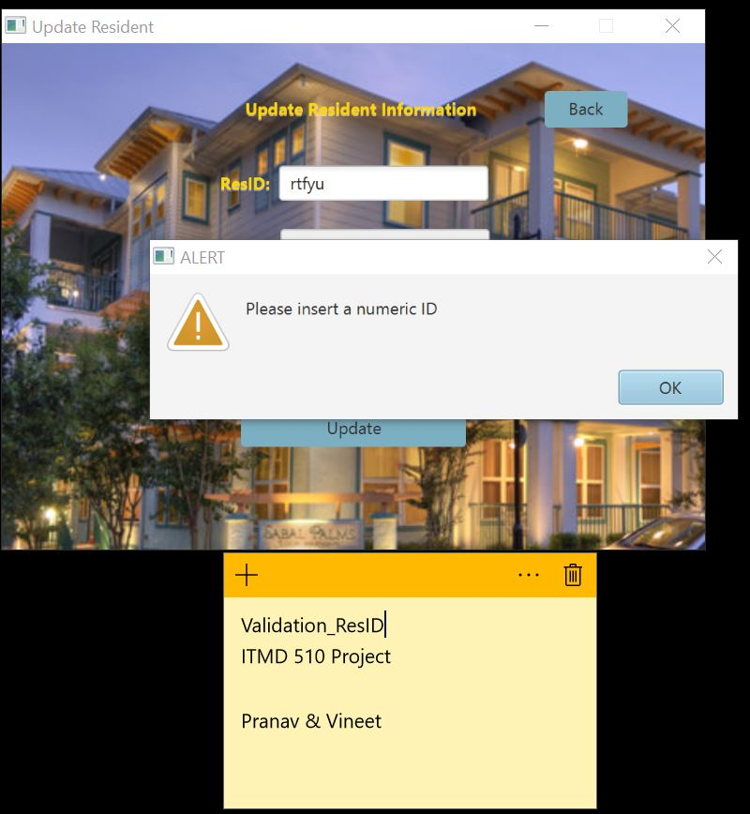

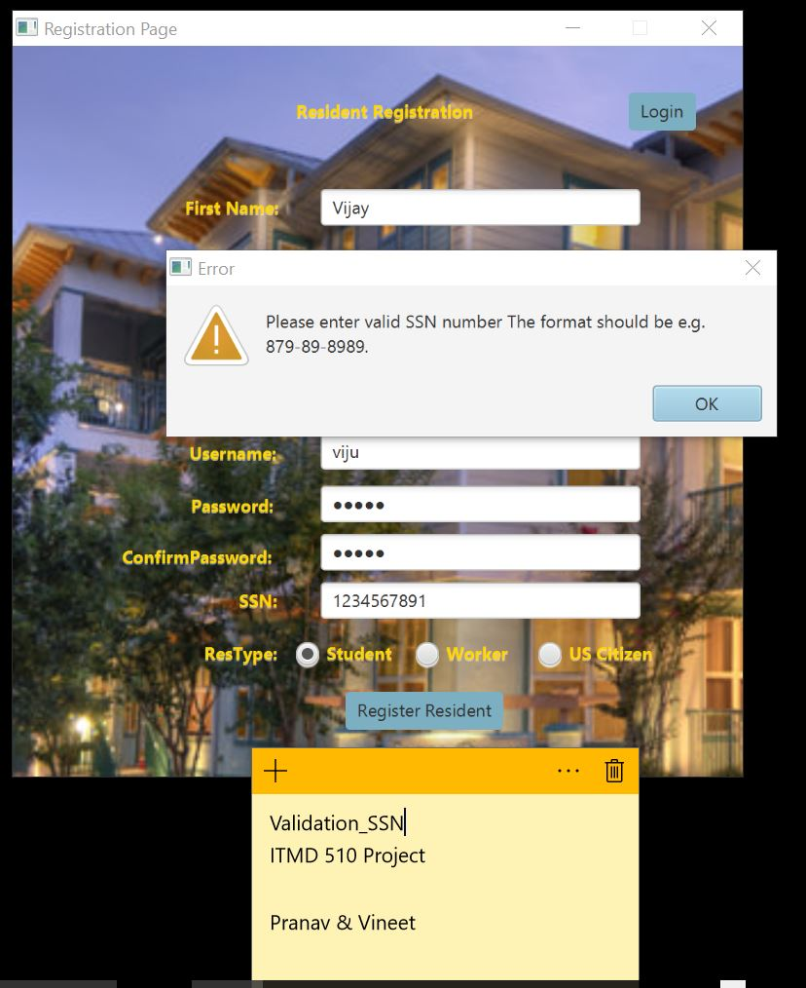

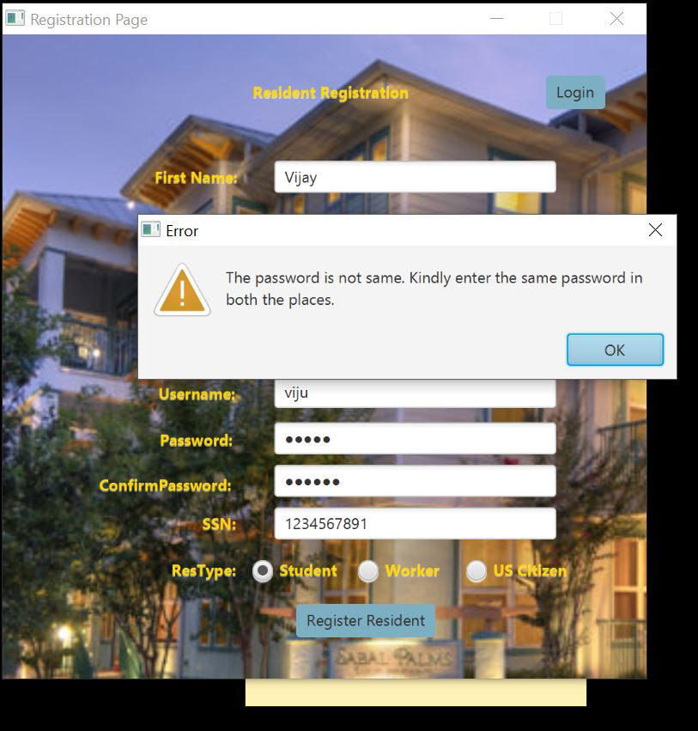

**Note: There are many Validation Check points which are there in our “Screenshot Folder”. Please refer them and run the code to verify.**

Future Scope:

* The Core Logic of this System can be used to upgrade this Desktop Application to Web Based Application.
* Housing and Rent Management can have charts that can give glimpse about the Number of Houses and the flats that are available for occupancy.
* This Analytics will help them to improve their services and work upon them to attract more number of Residents that would boost their profits.

Conclusion:

Thus, we have successfully implemented our Project “Housing and Rent Management System” that has various functionalities for Admin like Registering a New Resident, update their details, deleting their details if they leave our establishment, creating their Lease, updating it. Residents also have rights to register themselves, add complaints, maintenance request and view their current rent bill and pay accordingly.